PRESS RELEASE HYG29

HYGIENA’S ALLERFLOW QUICKLY DETECTS GLUTEN
IN FINAL RINSE WATER SAMPLES

As well as providing a rapid and convenient test for the detection of gluten residues on food processing surfaces, Hygiena’s AllerFlow Gluten is equally effective at detecting gluten in liquid samples, making it ideal for final rinse water samples. This means that the simplicity and convenience of AllerFlow Gluten can be applied to both surfaces and liquid samples and a wider range of food and beverage manufacturers.

AllerFlow Gluten is a rapid and convenient test for the detection of gluten as part of an allergen monitoring program. It is specific to the gliadin R12 allergenic fraction found in wheat, barley and rye, with no cross reactivity with soy, rice or corn. Unlike many commercial multi-component tests, AllerFlow makes gluten testing easier than ever before, due to the combination of Hygiena’s patented snap valve technology for convenient sample collection devices and classical lateral flow technology. Simply swab, snap and pour the fluid into the sample fill aperture on the cassette.

The result is seen in 10 minutes where a pass is indicated when a single blue line appears at ‘C’ (control), which means that the sample contains less than 5µg (5ppm) gluten. If the samples indicate greater than 5ppm gluten, then a red line will appear on the cassette indicating a fail and the more intense the colour, the more gluten is present.

Continued ……
For food and beverage processing equipment that has been cleaned-in-place (CIP), it is often difficult to collect a sample using a swab to verify the hygienic status. Under these circumstances, a representative sample can be obtained from the final rinse water that will have been in contact with internal surfaces. Laboratory tests and factory trials have shown that AllerFlow Gluten can also be used with 1 ml liquid samples without any loss of sensitivity detecting down to 5ppm. Rinse water samples have been used successfully by food manufacturers and also by brewers monitoring the change over from beer to cider processing to verify the absence of gluten residues in processing equipment.

AllerFlow Gluten complements other Hygiena tests for allergen control that offer a simple, rapid and cost effective verification. These include AllerSnap, a test for verifying allergens removed from surfaces and SuperSnap, for high-sensitivity ATP testing supporting allergen control.

For a copy of the white paper on allergen control and cleaning verification, please contact Hygiena at contactus@hygiena.com.

Further information is available on request to:
Hygiena International Ltd, Unit E, 3 Regal Way, Watford, Hertfordshire WD24 4YJ
Telephone: 01923 818821 Fax: 01923 818825

e-mail: contactus@hygiena.com www.hygiena.com Twitter: @HygienaInt

(approximately 470 words
including photographic annotations)

Continued ……
General Information

Supplier: Hygiena International Ltd

Press Release No: HYG29

Press or publishing inquiries to: Steve Lloyd
Enterprise Marketing Services Ltd
The Coach House, 1 Dunstall Road, Barton under Needwood,
Burton on Trent, Staffordshire, DE13 8AX, UK
Tel: +44 (0) 1283 713185
Fax: +44 (0) 1283 716172
e-mail: info@enterprise-marketing.co.uk

Reader response inquiries to: Mr Martin Easter, General Manager of Hygiena International Ltd

Downloads: The press release text (MS Word and PDF format) and images are
available for download at:

www.enterprise-marketing.co.uk/hyg/hyg29.html

Our Reference: HYG29/04/17/V2

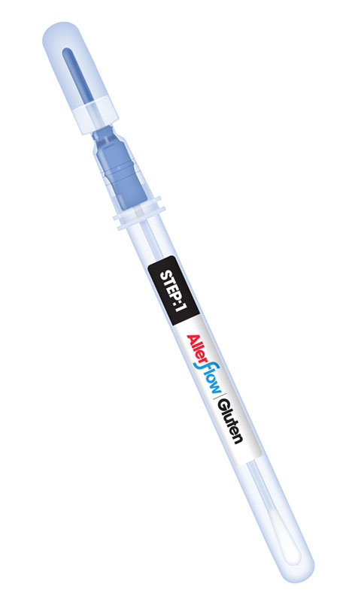
AllerFlow Gluten from Hygiena can detect gluten in liquid samples, making it ideal for final rinse water samples.
Download high resolution 300dpi image
Download low resolution 72dpi image
Continued ……
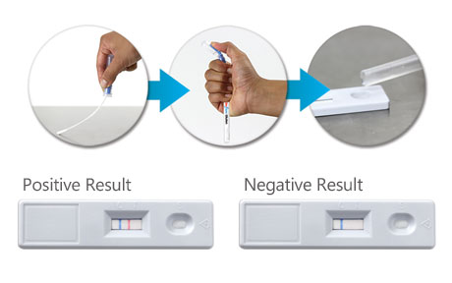
Simply swab, snap and pour into the sample fill on the cassette with easy to interpret results available in ten minutes.
Download high resolution 300dpi image
Download low resolution 72dpi image

END

Company Information

CELEBRATING SUCCESS

Building on >30 years of manufacturing experience in ATP bioluminescence, the company continues to innovate to develop simple rapid detection products and solutions for its customers.

Hygiena’s market leading qualities of proven high performance, repeatability and cost effectiveness have made it the system for choice for many leading blue chip companies around the world.
- 1st liquid stable ATP detection reagent (1999)
- 1st universal ATP reagent swab device (2000)
- 1st truly portable low cost ATP Hygiene monitoring system (SystemSURE, 2003; improved 2006)
- Independently verified and proven to give the best performance (2006, 2010, 2011)
- Business award recognition in several industries
- >100,000 systems sold (the world’s best selling ATP system)
- Range of simple colour hygiene tests
- New test platform for 21st Century
- New EnSURE instrument (2011)
- More sensitive reagent (SuperSnap) supporting allergen control
- Detection of microbes and specific bacteria in less than 8 hours (MicroSnap)
- Detection of process indicators minutes (ZymoSnap)

Hygiena’s mission is to supply products that deliver simplicity, convenience, excellent performance and value for money, backed-up by expert knowledge with first class service and support.

