PRESS RELEASE HYG27

SALMONELLA TESTING MADE FAST,
CONVENIENT AND ACCURATE

As salmonella bacteria are the most commonly reported cause of foodborne illnesses, never has testing been so important. However, while conventional salmonella test kits involve numerous complicated steps, Hygiena International’s recently developed InSite Salmonella micro-organism colorimetric test is rapid, convenient and extremely accurate. It combines both swab, pre-enrichment and selective enrichment in a single self-contained swab device for testing environmental surfaces, giving results in 24 hours.

Salmonella bacteria are found worldwide in a range of cold and warm-blooded animal species. In most cases, salmonella infections are contracted by ingesting poultry, pork, beef, fish or seafood that has not been heated/cooked appropriately, or was cross-contaminated after preparation. Eggs, milk, cheese, raw fruits, vegetables, spices and nuts can also harbour the bacteria. The resulting illness, Salmonellosis, is characterised by sometimes severe bouts of diarrhoea, fever, vomiting and abdominal cramps. According to the European Food Safety Authority, around 100,000 cases are reported every year in the EU.

Designed with the facts in mind, Hygiena InSite is a cost-effective Salmonella screening test for food contact surfaces, processing equipment and general environmental samples that combines the principal steps of pre-enrichment and selective enrichment in an all-in-one swab device. The test consists of a large sponge swab pre-wetted with a neutralising agent – to counter the effects of residual sanitisers – and a pre-enrichment broth to enable the detection of low numbers of Salmonella.

Continued ……
The bulb contains the AOAC enrichment Salmonella Indicator Broth PDX-SIB. After activation and incubation, a colour change of the selective enrichment broth from purple to yellow is considered as a ‘presumptive positive’ result.

A brief pre-enrichment period of just six hours enables the detection of presumptive positive samples within a 24-hour period. Alternatively, optional overnight or 24-hour pre-enrichment permits the detection of such samples in 48 hours. The test requires fewer materials, fewer steps and less manipulation by users. Furthermore, its all-in-one format maintains security by confining hazardous pathogens.

Screening for pathogens is a vital element of environmental monitoring programmes for certain food manufacturing plants. Not only does it confirm the effectiveness of a sanitation procedure, environmental monitoring also forms part of a comprehensive preventive control verification programme.

It is imperative that testing for the presence of Salmonella is carried out during facilities manufacturing and processing as well as wherever there is packing/holding of foods for consumption. However, while there are probably 40 different methods for salmonella detection currently commercially available, all require a skilled operator and are time-consuming, laborious and prone to errors at several stages.

In contrast, Hygiena InSite is quick, straightforward and reliable, while further benefits include reduced risk of cross-contamination and the retention of active culture for any subsequent verification and identification tests.

An instructional video explaining the product details and proper use of InSite Salmonella can be viewed at: http://www.hygiena.com/insite-salmonella-food-and-beverage.html

Continued ……
Further information is available on request to:
Hygiena International Ltd, Unit E, 3 Regal Way, Watford, Hertfordshire WD24 4YJ
Telephone: 01923 818821 Fax: 01923 818825

e-mail: contactus@hygiena.com www.hygiena.com Twitter: @HygienaInt

(approximately 530 words
including photographic annotations)

General Information

Supplier: Hygiena International Ltd

Press Release No: HYG27

Press or publishing inquiries to: Steve Lloyd
Enterprise Marketing Services Ltd
The Coach House, 1 Dunstall Road, Barton under Needwood,
Burton on Trent, Staffordshire, DE13 8AX, UK
Tel: +44 (0) 1283 713185
Fax: +44 (0) 1283 716172
e-mail: info@enterprise-marketing.co.uk

Reader response inquiries to: Mr Martin Easter, General Manager of Hygiena International Ltd

Downloads: The press release text (MS Word and PDF format) and images are
available for download at:

www.enterprise-marketing.co.uk/hyg/hyg27.html

Our Reference: HYG27/01/17/V3

Continued ……
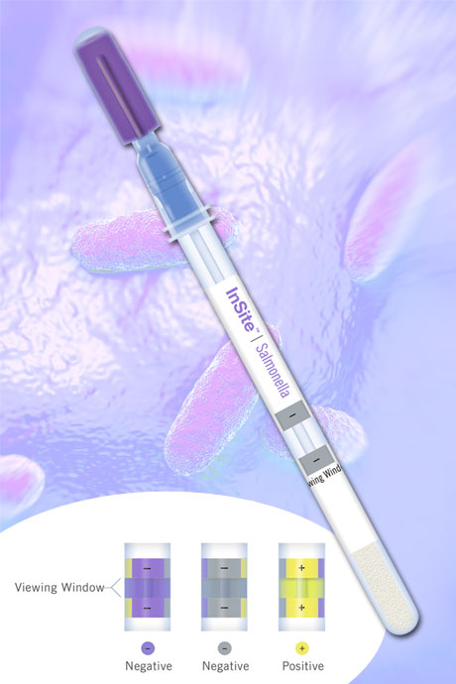
InSite Salmonella from Hygiena International is an easy-to-use, self contained, environmental Salmonella test.
Download high resolution 300dpi image
Download low resolution 72dpi image
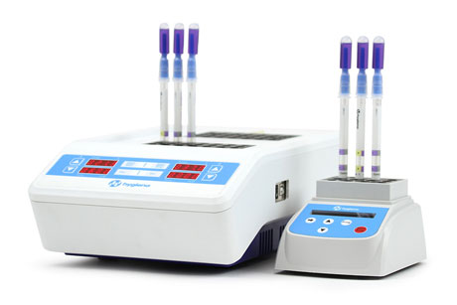
Digital dry block incubators, available in two sizes, for use with InSite Salmonella, Hygiena’s environmental Salmonella test.
Download high resolution 300dpi image
Download low resolution 72dpi image

END

Company Information

CELEBRATING SUCCESS

Building on >30 years of manufacturing experience in ATP bioluminescence, the company continues to innovate to develop simple rapid detection products and solutions for its customers.

Hygiena’s market leading qualities of proven high performance, repeatability and cost effectiveness have made it the system for choice for many leading blue chip companies around the world.
- 1st liquid stable ATP detection reagent (1999)
- 1st universal ATP reagent swab device (2000)
- 1st truly portable low cost ATP Hygiene monitoring system (SystemSURE, 2003; improved 2006)
- Independently verified and proven to give the best performance (2006, 2010, 2011)
- Business award recognition in several industries
- >80,000 systems sold (the world’s best selling ATP system)
- Range of simple colour hygiene tests
- New test platform for 21st Century
- New EnSURE instrument (2011)
- More sensitive reagent (SuperSnap) supporting allergen control
- Detection of microbes and specific bacteria in less than 8 hours (MicroSnap)
- Detection of process indicators minutes (ZymoSnap)

Hygiena’s mission is to supply products that deliver simplicity, convenience, excellent performance and value for money, backed-up by expert knowledge with first class service and support.

