PRESS RELEASE HYG26

IMPROVED HYGIENE STANDARDS ACHIEVED FOR
ANIMAL CARE AND BRAND PROTECTION

Everyone expects the highest standards of hygiene to be implemented in any healthcare setting, and the protection of patients, pet owners and staff within veterinary clinics is no different. Cleaning and disinfection should be monitored thoroughly and regularly with technology that permits objective measurement of any surface cleaning efficiency. ATP bioluminescence testing equipment from Hygiena International Ltd provides a simple rapid test for this purpose, with their products being well established in the healthcare sector for over 10 years.

High standards of hygiene and monitoring have been adopted in animal research and breeding centres, whereas the hygienic state of nearly 5500 UK veterinary premises is largely unknown to their owners, staff and users. Historic cases of MRSA infection in companion animals have led to litigation cases where poor hygiene could be substantiated. The prevalence of multidrug resistant bacteria is a present and major threat to human and animal wellbeing such that preventative measures are more important than ever.

The Federation of European Companion Animal Veterinary Association already recommends cleaning and disinfection. The Royal College of Veterinary Surgeons new Practice Standard Scheme is also a major initiative, and has auditing visits announced weeks in advance which do not appear to achieve any objective measurement standards for hygiene.

Auditable records of hygiene are not required or kept in most veterinary clinics with a high dependency on staff to be proactive. Experts and interest groups have made recommendations to improve hygiene but the means of assessment are subjective and not measurable.

Continued ……
The Hygiena ATP bioluminescence equipment provides a simple, rapid method for measuring surface area organic matter. It specifically measures adenosine triphosphate (ATP) which is the universal energy molecule present in all living things. The measurement equipment comprises a small hand held instrument and an all-in-one sample collection and testing device, which are capable of generating a numerical result in 15 seconds. It gives an objective yardstick and benchmark to describe and communicate levels of contamination and demonstrate what cleanliness really means. The use of ATP bioluminescence for cleaning verification is well established and has the highest recommendation by the Rapid Review Panel of the Dept of Health and Public Health England in support of the fight against HCAI. The test is also recognised by the CDC in USA and is written into a standard for cleaning in Denmark and Sweden.

It has enabled infection prevention and control staff to improve general hygiene, leading to lower infection rates, productivity improvement and cost savings. These same principles apply to veterinary care, where case studies show how easy it is to use the ATP hygiene monitoring equipment and achieve very rapid improvements. Veterinary infection control personnel judged this approach as ‘extremely useful in demonstrating tangible levels of hygiene’ and the need for improved cleaning.

Other users have commented “It’s a great benefit to have and instant measure of cleanliness. The results of ATP monitoring are incorporated into weekly infection prevention and control performance reports which are circulated to all concerned. It is there to encourage people and make them aware, while also adding a competitive edge to drive everyone to achieve a low score. If they’re doing a good job, the equipment registers a low score and the staff are delighted. The benefit is that with ATP monitoring, staff can react immediately to the results on-site and put any necessary interventions into immediate effect, and that way we’re safeguarding patients, which is what it is all about”.

Continued ……
ATP testing quickly highlights hot spots and helps change mindsets about hygiene. Most importantly, Hygiena’s SystemSURE and UltraSnap products deliver objective and digital results that can be managed as well as analyzed quickly with the included SureTrend software. The data generated provides an objective yardstick and benchmark from which the efficacy of intervention can be measured for continuous improvement. It generates auditable data for due diligence that is an essential part of good practice management. Overall the ATP systems maintain high quality, add value, reassure clients and protect the users business and brand.

To try the products for yourself, visit the Hygiena International and CliniTech Medical Stand C58 at the London Vet show taking place at ExCeL on 17 and 18 November 2016.

Further information is available on request to:
Hygiena International Ltd, Unit E, 3 Regal Way, Watford, Hertfordshire WD24 4YJ
Telephone: 01923 818821 Fax: 01923 818825

e-mail: enquiries@hygiena.net www.hygiena.com

(approximately 780 words
including photographic annotations)

General Information

Supplier: Hygiena International Ltd

Press Release No: HYG26

Press or publishing inquiries to: Steve Lloyd
Enterprise Marketing Services Ltd
The Coach House, 1 Dunstall Road, Barton under Needwood,
Burton on Trent, Staffordshire, DE13 8AX, UK
Tel: +44 (0) 1283 713185
Fax: +44 (0) 1283 716172
e-mail: info@enterprise-marketing.co.uk

Reader response inquiries to: Mr Martin Easter, General Manager of Hygiena International Ltd

Downloads: The press release text (MS Word and PDF format) and images are
available for download at:

www.enterprise-marketing.co.uk/hyg/hyg26.html

Our Reference: HYG26/10/16/V2

Continued ……
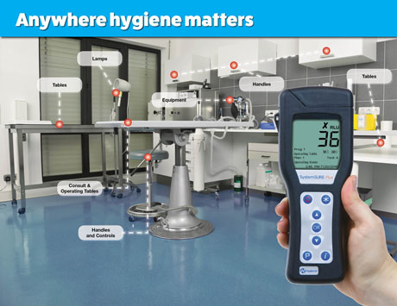
The Hygiena International hand-held device for measuring surface area ATP contamination with results indicated within 15 seconds.
Download high resolution 300dpi image
Download low resolution 72dpi image

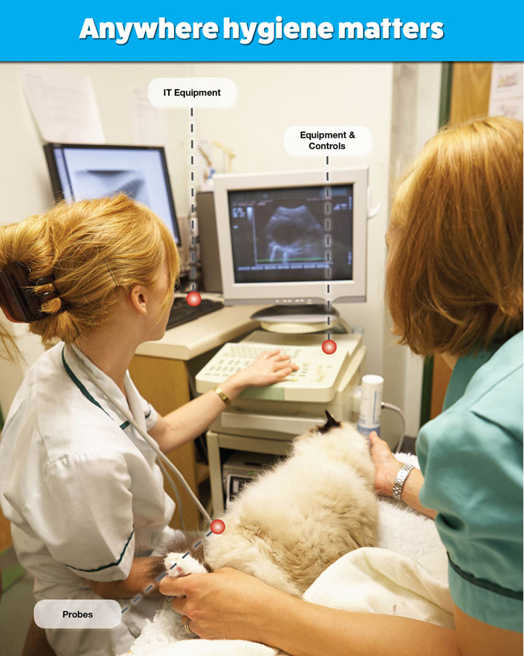
High levels of contact area cleanliness can now be achieved within animal care environments utilising Hygiena International ATP measuring devices.
Download high resolution 300dpi image
Download low resolution 72dpi image

END

Company Information

CELEBRATING SUCCESS

Building on >30 years of manufacturing experience in ATP bioluminescence, the company continues to innovate to develop simple rapid detection products and solutions for its customers.

Hygiena’s market leading qualities of proven high performance, repeatability and cost effectiveness have made it the system for choice for many leading blue chip companies around the world.
- 1st liquid stable ATP detection reagent (1999)
- 1st universal ATP reagent swab device (2000)
- 1st truly portable low cost ATP Hygiene monitoring system (SystemSURE, 2003; improved 2006)
- Independently verified and proven to give the best performance (2006, 2010, 2011)
- Business award recognition in several industries
- >80,000 systems sold (the world’s best selling ATP system)
- Range of simple colour hygiene tests
- New test platform for 21st Century
- New EnSURE instrument (2011)
- More sensitive reagent (SuperSnap) supporting allergen control
- Detection of microbes and specific bacteria in less than 8 hours (MicroSnap)
- Detection of process indicators minutes (ZymoSnap)

Hygiena’s mission is to supply products that deliver simplicity, convenience, excellent performance and value for money, backed-up by expert knowledge with first class service and support.

