PRESS RELEASE HYG24

QUICK HYGIENE TEST FOR THE BREWING INDUSTRY

Some of the major challenges for brewers are to make safe quality beer that maintains consumer confidence, while meeting retailer expectations and minimising both costs and wastage. This has been achieved in many microbreweries by using a simple rapid test, to determine the hygienic quality of their production equipment and working surface areas.

Langham Brewery is a successful small independent steam-powered microbrewery situated between the West Sussex towns of Midhurst and Petworth in the beautiful South Downs National Park. Lesley Foulkes and James Berrow, Langham Brewery’s partners, attribute much of the brewery’s success in producing quality and consistent beer to maintaining high sanitation processes and keeping the busy brewery operations spic and span. A core part of these processes is achieved utilising the SystemSURE Plus products from Hygiena International for the quick and accurate ATP testing of surface areas.

Langham have been using Hygiena International’s cleaning systems since 2008. ATP testing is a simple and affordable test method which verifies cleaning effectiveness in seconds. The science is based on the detection of organic residues on surfaces and in water samples using a bioluminescent reaction. Pen-shaped test devices contain a modified firefly enzyme that reacts with organic material to produce light, which is then measured in a handheld meter (called a luminometer) about the size of a TV remote control. The luminometer converts the light output into an RLU number (Relative Light Unit): the lower that number, the cleaner the surface (or less contamination in the water sample if a CIP system is being tested).

Continued ……
The brewery relies on quick turnaround. As soon as a tank is emptied it is immediately deep cleaned ready for the next beer. The brewing team all are trained how to use the ATP meter to instantly validate their cleaning procedure. The ATP meter indicates what is clean and what is not clean. If occasionally a higher ATP level is indicated then another caustic cleaning cycle is undertaken, until the score gives confidence that the vessel is clean enough to ensure the quality and consistency of the next brew.

Established in 2005, Langham Brewery has been trading for eight years and is well known for its award winning beer – having more than 22 awards to its name, with six in 2015 alone! Its mission is to produce innovative, distinctive and flavoursome cask-conditioned real ales using the finest quality ingredients and traditional craft skills.

The brewery was hand-picked by the Food Certification Body SALSA (Safe and Local Supplier Approval), Cask Marque and SIBA as one of only 4 breweries to trial a new brewery focused standard for beer, “SALSA plus Beer”. They successfully achieved this, and the standard was launched across the UK on the 30th of June 2015. SALSA plus Beer allows small breweries and bottlers across the UK to follow a dedicated standard that gives confidence to customers and retailers that their beer is safe, and more importantly, of excellent quality and consistency. The aim is two-fold: to raise quality and compliance standards within the sector and to provide strengthened confidence for both retailers and ‘on trade’ buyers.

SALSA is a recognised food safety certification scheme that is widely accepted by both retailers and food service providers. It is a joint venture between four major trade associations representing the UK food chain and is administered and operated by the Institute of Food Science and Technology. A core element of the SALSA standard is strong and provable hygiene.

For Langham Brewery, the peace of mind brought by the SystemSURE ATP quick validation tool reinforces confidence in Langham’s quality control systems, and what better proof of that than their SALSA plus Beer accreditation.
Continued ……
The practical benefits of ATP hygiene monitoring have been well proven and established for over 20 years. Ogden et al (1993) at the Green King brewery showed that the technology was used to change the assessment of brewery hygiene from a “retrospective exercise into a positive preventative measure” because “it detects ‘soil’ and not just microorganisms, it is likely to give a more accurate representation of the condition of the plant”. Any unacceptable soiling is detected and used to positively release equipment into manufacturing. Over a one year period, the improvement in the pass rate on different vessels ranged from 27% to 90%. One recurring problem was found to cause 50% of all failure and it was quickly identified and remedied. The benefit from the ATP test included:
- Financial savings due to improved quality control and avoidance of spoilage
- Improved production efficiency (right first time)
- Improved confidence in product quality
- Increased motivation and productivity of staff

Further information is available on request to:
Hygiena International Ltd, Unit E, 3 Regal Way, Watford, Hertfordshire WD24 4YJ
Telephone: 01923 818821 Fax: 01923 818825

e-mail: enquiries@hygiena.net www.hygiena.com/beer

FURTHER INFORMATION
Hygiena is a microbiology and life science company that serves industrial food processors, healthcare institutions, sanitation suppliers, life science researchers and the general public. Hygiena manufactures and sells a broad range of rapid monitoring systems, environmental collection devices, and rapid dilution devices. Hygiena is committed to the mission of providing customers with innovative technologies that are simple, easy-to-use, and reliable, with excellent customer service and support. All products are made under strict GMP standards, ensuring excellent product quality and reliability. With offices in the US, UK, China, India, and over 100 distributors worldwide, Hygiena products span the globe. For more information visit www.hygiena.com

Watch product demos and instructional videos at www.youtube.com/HygienaTV
Follow Hygiena USA on twitter @HygienaUSA

(approximately 840 words
including photographic annotations)

Continued ……
General Information

Supplier: Hygiena International Ltd

Press Release No: HYG24

Press or publishing inquiries to: Steve Lloyd
Enterprise Marketing Services Ltd
The Coach House, 1 Dunstall Road, Barton under Needwood,
Burton on Trent, Staffordshire, DE13 8AX, UK
Tel: +44 (0) 1283 713185
Fax: +44 (0) 1283 716172
e-mail: info@enterprise-marketing.co.uk

Reader response inquiries to: Mr Martin Easter, General Manager of Hygiena International Ltd

Downloads: The press release text (MS Word and PDF format) and images are
available for download at:

www.enterprise-marketing.co.uk/hyg/hyg24.html

Our Reference: HYG24/03/16/V1

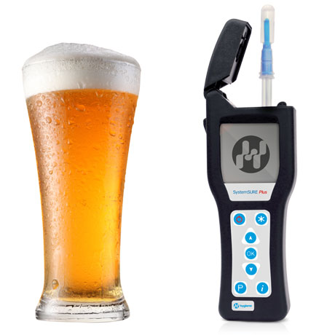

Langham Brewery has been using Hygiena International’s cleaning systems since 2008.
Download high resolution 300dpi image
Download low resolution 72dpi image
Continued ……
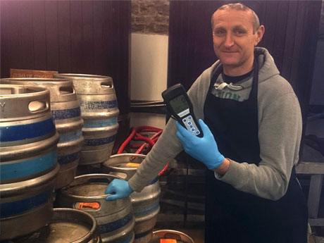

The Hygiena SystemSURE Plus in use at Langham Brewery.
Download high resolution 300dpi image
Download low resolution 72dpi image

Continued ……

Company Information

CELEBRATING SUCCESS

Building on >30 years of manufacturing experience in ATP bioluminescence, the company continues to innovate to develop simple rapid detection products and solutions for its customers.

Hygiena’s market leading qualities of proven high performance, repeatability and cost effectiveness have made it the system for choice for many leading blue chip companies around the world.
- 1st liquid stable ATP detection reagent (1999)
- 1st universal ATP reagent swab device (2000)
- 1st truly portable low cost ATP Hygiene monitoring system (SystemSURE, 2003; improved 2006)
- Independently verified and proven to give the best performance (2006, 2010, 2011)
- Business award recognition in several industries
- >60,000 systems sold
- Range of simple colour hygiene tests
- New test platform for 21st Century
- New EnSURE instrument (2011)
- More sensitive reagent (SuperSnap) supporting allergen control
- Detection of microbes and specific bacteria in less than 8 hours (MicroSnap)
- Detection of process indicators minutes (ZymoSnap)

Hygiena’s mission is to supply products that deliver simplicity, convenience, excellent performance and value for money, backed-up by expert knowledge with first class service and support.

