PRESS RELEASE HLI68

GIVE WORKPLACES A CLEAN BILL OF HEALTH
With the UK Government continuing to ease lockdown measures, increasing numbers of companies and commercial premises are opening for business after a hiatus due to COVID-19. To help protect the health of those making their way back to the office, factory, shop, pub, gym or any other place of work, a new ultra-effective surface sanitiser – Hi-KLEEN – is being introduced by Hi-line Industries. Spraying a single coating of HI-KLEEN on to surfaces such as doors, handles, handrails, chairs and desks will not only kill coronavirus, it will provide protection against further contamination for up to five hours.

Hi-KLEEN has been specially formulated to kill and inhibit both bacteria and viruses (including enveloped viruses such as coronavirus) on hard or soft surfaces subject to frequent contact. Simply spray at a distance of approximately 10–20 cm from the surface to be treated for effective protection. This odour-free, clear product is ideal for offices, factories (including food plants), conference centres, sports clubs, hospitals, health centres, educational facilities, care homes, entertainment/hospitality venues (including restaurants and pubs), and even transport.

Notably, active biocides present in the formulation provide longer-lasting protection than alcohol-based preparations. Hi-line’s new surface sanitiser does not stain, is non-corrosive and will give a streak and smear-free finish to most polished surfaces, including glass and stainless steel. The product is safe to use and alcohol-free, meaning that there is no drying or irritation to the skin.

Continued……

To provide proof of efficacy in the control of harmful micro-organisms, HI-KLEEN has been tested to BS EN 1276, which is the European standard for the bactericidal activity of chemical disinfectants. In order to meet the standard, products are tested by an independent laboratory and must kill 99.999% of bacteria within 5 minutes.

Composed of organic, non-chlorinated solvents, HI-KLEEN is offered by Hi-line Industries in both 500ml aerosols and disposable 17kg canisters. The latter is particularly useful for those looking to sanitise entire rooms, providing a typical coverage of 750 square metres. Canisters are connected by either a 3.5 or 5.5 metre hose to a spray gun, delivering an easy-to-use, self-contained, time-saving spraying system that requires minimal set-up.

Any business owners or managers worried about controlling the spread of COVID-19 as the country returns to work can rely on HI-KLEEN to keep surfaces and rooms free of harmful contamination, in turn protecting the health of staff and visitors alike.

Further information is available from: Hi-line Industries Ltd,
Green Street, Burton on Trent, Staffordshire DE14 3RT
Telephone: 01283 533377 Fax: 01283 533367
e-mail: enquiries@hilineindustries.com www.hilineindustries.com

(approximately 460 words
including photographic annotations)

Continued……
General Information

Supplier: Hi-line Industries Ltd

Press Release No: HLI68

Press or publishing inquiries to: Steve Lloyd
Enterprise Marketing Services Ltd
Studio 3, Unit 7, Waterside Court, Third Avenue,
Centrum One Hundred, Burton on Trent, DE14 2WQ, UK
Tel: +44 (0) 1283 713185
E-mail: info@enterprise-marketing.co.uk

Reader response inquiries to: Mr Steven D Smith
Sales & Marketing Director of Hi-line Industries Ltd

Downloads: The press release text (MS Word and PDF format) and images are
available for download at:

www.enterprise-marketing.co.uk/hli/hli68.html

Our Reference: HLI68/20/06/V2

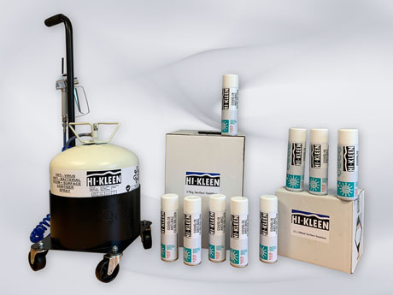
Hi-KLEEN from Hi-line Industries a new ultra-effective surface sanitiser available in both 500ml aerosols and disposable 17kg canisters.
Download high resolution 300dpi image
Download low resolution 72dpi image

Continued……
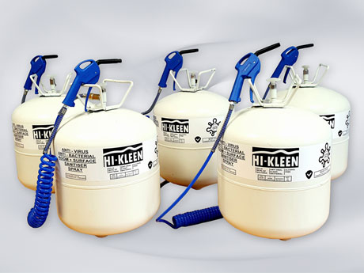
Hi-KLEEN has been specially formulated to kill and inhibit both bacteria and viruses hard or soft surfaces subject to frequent contact.
Download high resolution 300dpi image
Download low resolution 72dpi image

END

