PRESS RELEASE HLI64

HI-LINE WELCOMES THREE NEW APPOINTMENTS
AND CELEBRATES LATEST SAFETY ACCREDITATION

Hi-line Industries, a leading UK supplier to the compressed air sector, has welcomed three new employees to its ranks. Reflecting the company’s ongoing success and growth, Stephen Martin joins as Sales Director, Matt Johnson takes up the title of Project Engineer while Brad Beesley arrives as Internal Sales Co-ordinator. The news comes in the same week as Hi-line celebrates its latest safety award: the company has been granted the prestigious SafeContractor accreditation by Alcumus.

The upward trajectory of Hi-line Industries Ltd has been noted across the sector. The company moved into a new, much larger production facility last year in order to meet growing demand for its range of highly efficient compressed air purification equipment. Hi-line is acknowledged as Britain’s largest stockist of a broad range of air treatment ancillaries, and the largest supplier of refrigeration air dryers.

At a time when the company continues to grow year-on-year, recording a record turnover for its most recent financial year, the company decided to further extend its strength in sales by appointing Stephen Martin as Sales Director, a move that Hi-line hopes will capture even more market share for the business.

Stephen has a wealth of experience within the compressed air and dehydration market having worked in the industry for over 30 years. He stared his career in compressor distribution and filtration, running his own compressor agency, before selling to join SPXFLOW, where he spent 23 years supporting the company’s dehydration distributor and direct project business.
Continued……

“I’m looking forward to the opportunities that my new role will provide,” says Stephen. “I’ve been tasked with looking after Hi-line's interests throughout the UK and I’m keen to meet our wide and varied client base over the coming months.”

Also joining the Hi-line team is Matthew Johnson, who becomes Project Manager. Matthew started his career in the Royal Navy before moving into construction and engineering. He commenced an adult apprenticeship, aged 21, in electrical maintenance engineering before going on to study a HNC and HND in mechanical engineering at Sheffield Hallam University. Following six years as a maintenance engineer Matthew decided to move into a more managerial role and spent the past two years as a project engineer at a maltsters in Burton upon Trent, where he handled and delivered multiple capex projects varying in cost and size.

“I’m a firm believer in the work hard, play hard ethic, and I come to Hi-line Industries with the same drive and ambition as I did when I began my career,” says Matthew. “I know I have the passion and determination to make an impact.”

Having worked in the ink industry for five years, Brad worked his way through the ranks from Warehouse Operative to Account Sales Manager, and joins Hi-line as Internal Sales Co-ordinator. “I am looking forward to building strong relationships with new and existing customers in my new role.” says Brad. “I understand the importance of meeting customers’ needs and will go the extra mile to ensure I do that”.

Arriving at the same time as its new recruits, the SafeContractor accreditation builds on the Hi-line ethos of safety first. After all, when it comes to the manufacture, installation and maintenance of pressurised systems, there is no margin for error. Awarded in July 2019, SafeContractor is latest endorsement of Hi-line’s comprehensive safety standards.

Continued……
Further information is available from: Hi-line Industries Ltd,
Green Street, Burton on Trent, Staffordshire DE14 3RT
Telephone: 01283 533377 Fax: 01283 533367
e-mail: enquiries@hilineindustries.com www.hilineindustries.com

(approximately 600 words
including photographic annotations)

General Information

Supplier: Hi-line Industries Ltd

Press Release No: HLI64

Press or publishing inquiries to: Steve Lloyd
Enterprise Marketing Services Ltd
The Coach House, 1 Dunstall Road, Barton under Needwood,
Burton on Trent, Staffordshire, DE13 8AX, UK
Tel: +44 (0) 1283 713185
Fax: +44 (0) 1283 716172
E-mail: info@enterprise-marketing.co.uk

Reader response inquiries to: Mr Steven D Smith
Sales & Marketing Director of Hi-line Industries Ltd

Downloads: The press release text (MS Word and PDF format) and image are
available for download at:

www.enterprise-marketing.co.uk/hli/hli64.html

Our Reference: HLI64/19/08/V5

Continued……
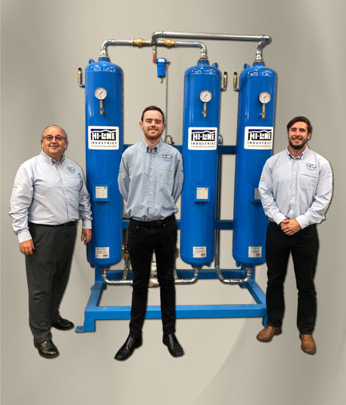
Hi-line has welcomed two new employees to its ranks. Stephen Martin joins as Sales Director, Matt Johnson takes up the title of Project Engineer while Brad Beesley arrives as Internal Sales Co-ordinator.
Download high resolution 300dpi image
Download low resolution 72dpi image

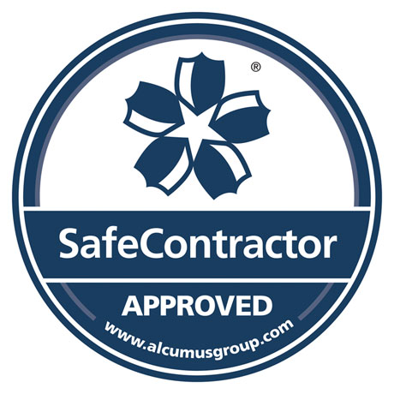
Hi-line celebrates its latest safety award: the company has been granted the prestigious SafeContractor accreditation by Alcumus.
Download high resolution 300dpi image
Download low resolution 72dpi image

END

