PRESS RELEASE HLI63

ACTIVATED CARBON TOWERS NOW AVAILABLE FROM HI-LINE

Hi-line Industries, a leading UK supplier to the compressed air sector, has unveiled a range of Activated Carbon Towers to suit a number of diverse applications, including those involving breathing air equipment or food production, for example. The new carbon towers are manufactured from the same high-quality vessels used for Hi-line’s dryers, and filled with either zeolite minerals or carbon to suit the suit the specific application.

Activated Carbon Towers are an increasingly popular addition to compressed air circuits, thanks largely to their ability to adsorb contaminants such as oil vapour and odour. As a result, oil levels within the compressed air can be reduced sufficiently for use in sectors where high purity levels are required, like oxygen/nitrogen generation, food and beverage, pharmaceuticals, electronics and healthcare. Such performance levels exceed those possible using desiccant air dryers together with associated filtration.

In the new units, compressed air flows through the activated carbon bed, adsorbing oil vapours and odours. Flow distributors are deployed to ensure uniform air distribution. Some 15 models are available in the range, extending from the smallest at a capacity of 80 Scfm, 136 Nm3/h, up to the largest, at 2000 Scfm, 3400 Nm3/h. The units come with stainless steel gas distributors and are PED compliant to 2016/68 EU, while R55 long-life hybrid activated carbon is used to ensure reliable performance, day-in, day-out. A five-year warranty is offered as standard on parts and labour.

Continued……
Vessels are held in stock at Hi-line Industries to ensure short lead-times. Both the vessels and the robust box section frame are powder-coat finished in RAL 5015, although they can be manufactured in any colour at no extra charge.

Further information is available from: Hi-line Industries Ltd,
Green Street, Burton on Trent, Staffordshire DE14 3RT
Telephone: 01283 533377 Fax: 01283 533367
e-mail: enquiries@hilineindustries.com www.hilineindustries.com

(approximately 320 words
including photographic annotation)

General Information

Supplier: Hi-line Industries Ltd

Press Release No: HLI63

Press or publishing inquiries to: Steve Lloyd
Enterprise Marketing Services Ltd
The Coach House, 1 Dunstall Road, Barton under Needwood,
Burton on Trent, Staffordshire, DE13 8AX, UK
Tel: +44 (0) 1283 713185
Fax: +44 (0) 1283 716172
E-mail: info@enterprise-marketing.co.uk

Reader response inquiries to: Mr Steven D Smith
Sales & Marketing Director of Hi-line Industries Ltd

Downloads: The press release text (MS Word and PDF format) and image are
available for download at:

www.enterprise-marketing.co.uk/hli/hli63.html

Our Reference: HLI63/19/03/V2

Continued……
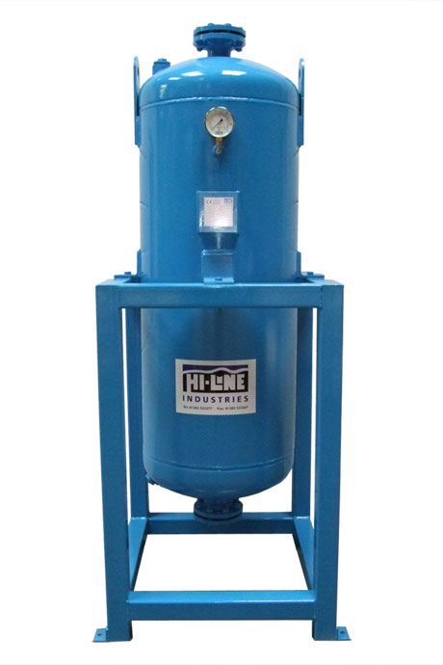
Activated Carbon Towers from Hi-line Industries are now available to suit a diverse range of applications.
Download high resolution 300dpi image
Download low resolution 72dpi image

END

