PRESS RELEASE HLI62

VERTICAL AIR RECEIVERS NOW IN STOCK
AT HI-LINE INDUSTRIES

As a company that listens carefully to changes in market demands and industry trends, Hi-line Industries now holds a range of class-leading Vertical Air Receivers in stock. The top-quality vessels are available immediately at highly competitive prices.

Currently, four sizes of Vertical Air Receivers are being stocked at Hi-line: 300, 500, 1000 and 2000 litre variants. The vessels are manufactured at Hi-line’s new factory, centrally located in Burton-upon-Trent where the company has a storage facility populated with the vessels ready for immediate shipping or collection.

Receivers provide valuable temporary storage for compressed air, particularly at facilities with high air consumption. The vessels also serve to stabilise pressure peaks and provide steady air flow. Not having one as part of a compressed air system can increase the load/unload cycles on the compressor, making it work harder.

All of the Vertical Air Receivers stocked by Hi-line are powder-coat finished in compressed air blue (RAL 5015) and are PED compliant to 2014/68/EU. Indeed, quality is the primary attribute of the vessels, which are built by robots to ensure perfect and consistent welding quality. In addition, high-quality 5mm plate and fittings are used throughout. As a result of this build quality, the Vertical Air Receivers are twice the weight (pro rata) of standard catalogue vessels.

Continued……

All four models of Vertical Air Receiver being stocked by Hi-line Industries offer 11 bar working pressure and come with a 10-year warranty. The vessels can be supplied with or without fitting kits to suit individual preferences. Safety valves, gauges and drains are also available as options.

As a member of the British Compressed Air Society, Hi-line is proud to be part of the ‘Made in Britain’ campaign that promotes the best of British manufacturing.

Further information is available from: Hi-line Industries Ltd,
Green Street, Burton on Trent, Staffordshire DE14 3RT
Telephone: 01283 533377 Fax: 01283 533367
e-mail: enquiries@hilineindustries.com www.hilineindustries.com

(approximately 340 words
including photographic annotation)

General Information

Supplier: Hi-line Industries Ltd

Press Release No: HLI62

Press or publishing inquiries to: Steve Lloyd
Enterprise Marketing Services Ltd
The Coach House, 1 Dunstall Road, Barton under Needwood,
Burton on Trent, Staffordshire, DE13 8AX, UK
Tel: +44 (0) 1283 713185
Fax: +44 (0) 1283 716172
E-mail: info@enterprise-marketing.co.uk

Reader response inquiries to: Mr Steven D Smith
Sales & Marketing Director of Hi-line Industries Ltd

Downloads: The press release text (MS Word and PDF format) and image are
available for download at:

www.enterprise-marketing.co.uk/hli/hli62.html

Our Reference: HLI62/19/01/V2

Continued……
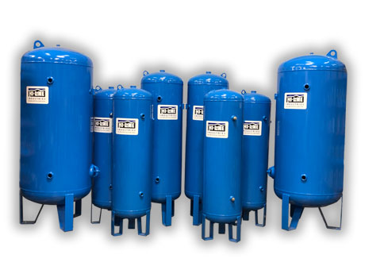
The new range of class-leading Vertical Air Receivers from Hi-line Industries.
Download high resolution 300dpi image
Download low resolution 72dpi image

END

