PRESS RELEASE HLI61

IN-HOUSE N2/O2 GENERATION PAYS DIVIDENDS
WITH HI-LINE TECHNOLOGY

Any company looking to invest in the latest high-purity, low-energy nitrogen and oxygen generators should look no further than the latest series from Hi-line Industries. Hi-line’s N2/O2 generators use simple Pressure Swing Adsorption (PSA) technology to help ensure there is no longer any reason to pay for bottled gas or bulk nitrogen/oxygen tanks ever again.

Nitrogen and oxygen are two of the planet’s most abundant gases, yet many businesses spend thousands in having it delivered, typically in cylinders or bulk tanks. Paying top prices for something that is essentially free simply does not make commercial sense.

Generating on-site nitrogen and oxygen is a safe and simple process, and while nothing is for free, the potential savings to be made against bottle/tank deliveries are staggering. However, an N2/O2 generator needs to be correctly specified if the gains are to be maximised.

To highlight the advantages of a well specified system, consider the topic of gas purity. Most of the large gas-producing companies only offer N2 at UHP (Ultra High Purity) of 99.99999%. There is no other option. However, the application in hand may only require a purity of only 98% or 95%. When Hi-line designs an N2 system, the cost of a 98% generator against a 99.99999% generator of the same flow is 10 times cheaper.

Continued……

Hi-line N2 generators utilise completely different control technology to traditional PSA N2 generators. A variable speed type technology is used, where the generator only runs when the process is calling for N2, and when no N2 requirement is needed, the Hi-line generator goes on to stand-by. On start up, N2 at the exact purity required is delivered due to a buffer/polishing tank along with a high purity storage vessel on the skid, meaning no down-time whilst waiting to reach purity, unlike some technologies.

Bottled gas is sold at high pressure, to enable smaller footprint, and regulated down. However, if your did need a 30 – 40 bar application, then Hi-line can add a booster to the skid to give you the exact pressure required at your process.

The cycle is therefore continuously producing high-quality nitrogen, 24 hours a day. Used correctly, the CMS is fully regenerative and has a life span over 40,000 operational hours. Nitrogen gas is used in a wide range of industries where safe, inert environments are required, such as the petroleum, chemical, pharmaceutical, paint and varnish sectors, as well as in the production of ferrous and non-ferrous metals, together with electronic and glass products.

Aside from the huge cost advantages available, there are a multitude of advantages associated with in-house N2/O2 generation, not least independence from third-party gas supplies and market price fluctuations. There is also the elimination of logistical tasks associated with bottles or liquid nitrogen, as well as the management of suppliers. In addition, the equipment is modular and flexible, and has very low maintenance requirements.

Highlighting the potential savings on offer, a renowned food packaging company was spending over £120,000 having N2 delivered to site via a tanker four times a week. Required for MAP (Modified Atmosphere Packaging) processes, the plant turned to Hi-line for an alternative solution. Hi-line was able to supply an N2 generator skid for a one-off fee of £55,000. Now, the company can produce its own N2 only for the cost of compressed air; a huge saving year-on-year.

Continued……
As a manufacturer, Hi-line is able to design bespoke generator systems for customers that ensure the lowest possible running costs and smallest footprint. Manufacturing takes place at the company’s new facility, which is three times the size of Hi-line’s previous headquarters. The new plant is located centrally in Burton-upon-Trent, Staffordshire, with excellent access to the UK motorway network.

Hi-line is a member of the British Compressed Air Society, and proud to be part of the ‘Made in Britain’ campaign that promotes the best of British manufacturing.

Further information is available from: Hi-line Industries Ltd,
Green Street, Burton on Trent, Staffordshire DE14 3RT
Telephone: 01283 533377 Fax: 01283 533367
e-mail: enquiries@hilineindustries.com www.hilineindustries.com

(approximately 680 words
including photographic annotations)

General Information

Supplier: Hi-line Industries Ltd

Press Release No: HLI61

Press or publishing inquiries to: Steve Lloyd
Enterprise Marketing Services Ltd
The Coach House, 1 Dunstall Road, Barton under Needwood,
Burton on Trent, Staffordshire, DE13 8AX, UK
Tel: +44 (0) 1283 713185
Fax: +44 (0) 1283 716172
E-mail: info@enterprise-marketing.co.uk

Reader response inquiries to: Mr Steven D Smith
Sales & Marketing Director of Hi-line Industries Ltd

Downloads: The press release text (MS Word and PDF format) and images are
available for download at:

www.enterprise-marketing.co.uk/hli/hli61.html

Our Reference: HLI61/18/11/V2

Continued……

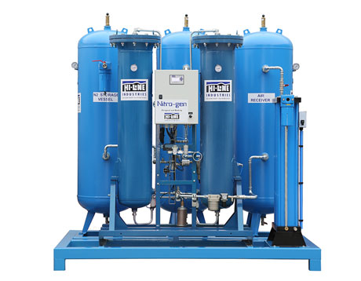
The latest high-purity, low-energy nitrogen and oxygen generators from Hi-line Industries offer low running cost.
Download high resolution 300dpi image
Download low resolution 72dpi image

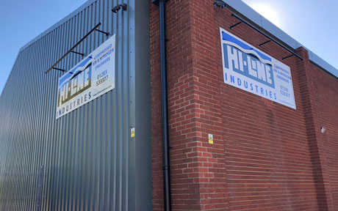
The new Hi-line factory in Burton on Trent where their oxygen and nitrogen generators, featuring simple Pressure Swing Adsorption (PSA) technology are manufactured.
Download high resolution 300dpi image
Download low resolution 72dpi image

END

