PRESS RELEASE HLI60

HI-LINE RELOCATES TO LARGER PRODUCTION FACILITY

Hi-line Industries Ltd has moved into a new, larger production facility in order to meet growing demand for its range of highly efficient compressed air purification equipment. The new premises is three times the size of the company’s previous headquarters, ensuring that Hi-line will continue meeting the needs of customers in sectors such as food, beverage, medical, general engineering, dairy, automotive and laser cutting.

Hi-line designs, manufactures, supplies and installs a broad range of energy-efficient compressed air equipment that includes air dryers, nitrogen/oxygen generators, compressed air filtration equipment, condensate management/drains and service kits. With demand for the company’s innovative, UK-made products continuing to grow, Hi-line sought to invest in its future by relocating to a facility that would not only allow existing production to expand, but facilitate a forthcoming extension to its class-leading product range.

The new facility is located centrally in Burton-upon-Trent, Staffordshire, with excellent access to the A38, A50, M1 and wider UK motorway network. An immediate benefit of the move is that lead-times will be further reduced on Hi-line’s range of dryer and generator products. In addition, the relocation has created many more jobs locally and allowed the company to take on twice as many apprentices this year. Importantly, there is also large trade counter and customer pick-up centre at the new site, ensuring that Hi-line continues its customer-centric focus.

The significant investment in new premises has been supported by various grants for energy efficiency and investing in people and the original Hi-line factory will be used for additional warehousing for refrigeration air dryers.
Continued……
Hi-line is acknowledged as Britain’s largest stockist of a broad range of air treatment ancillaries, and the largest supplier of refrigeration air dryers, as distributed via its established network of compressed air agents. The company is also a member of the British Compressed Air Society, and proud to be part of the ‘Made in Britain’ campaign promoting the best of British manufacturing.

Utilising the latest 3D CAD software, combined with ongoing investments in personnel, training and development, Hi-line has the best technology and expertise to undertake the development of innovative products and remain at the leading edge of the industry. All of the ISO9001-accredited company’s products are designed and built to the highest standards of quality by experienced and qualified engineers. This ethos is reflected in Hi-line’s five year warranty, ensuring long-term piece of mind for customers.

Hi-line can offer both a standard and bespoke range of energy-efficient products built to suit specific applications.

Further information is available from: Hi-line Industries Ltd,
Green Street, Burton on Trent, Staffordshire DE14 3RT
Telephone: 01283 533377 Fax: 01283 533367
e-mail: enquiries@hilineindustries.com www.hilineindustries.com

(approximately 490 words
including photographic annotations)

Continued……
General Information

Supplier: Hi-line Industries Ltd

Press Release No: HLI60

Press or publishing inquiries to: Steve Lloyd
Enterprise Marketing Services Ltd
The Coach House, 1 Dunstall Road, Barton under Needwood,
Burton on Trent, Staffordshire, DE13 8AX, UK
Tel: +44 (0) 1283 713185
Fax: +44 (0) 1283 716172
E-mail: info@enterprise-marketing.co.uk

Reader response inquiries to: Mr Steven D Smith
Sales & Marketing Director of Hi-line Industries Ltd

Downloads: The press release text (MS Word and PDF format) and images are
available for download at:

www.enterprise-marketing.co.uk/hli/hli60.html

Our Reference: HLI60/18/10/V2

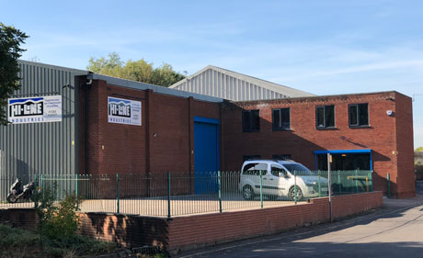
The new Hi-line Industries premises will provide a larger production facility in order to meet growing demand for its range of highly efficient compressed air purification equipment.
Download high resolution 300dpi image
Download low resolution 72dpi image

Continued ……
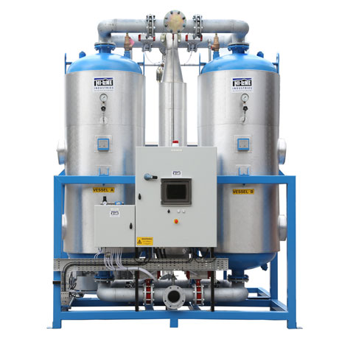
Typical desiccant air dryer from the Hi-line range of compressed air products, manufactured from their new larger production facility.
Download high resolution 300dpi image
Download low resolution 72dpi image

END

