PRESS RELEASE HLI59

SELECTING COMPRESSED AIR PURIFICATION TO
ISO QUALITY STANDARDS

The international standard for compressed air quality, ISO 8573:2010, is the primary documentation to facilitate compressed air systems component selection, design and performance measures. Hi-line Industries, UK manufacturer of high-quality compressed air purification equipment have been working closely with the British Compressed Air Society to produce a best practice guide for the filtration and drying of compressed air.
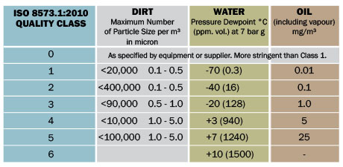
The ISO standard introduces a simple system of classification for the three main contaminants present in any compressed air system – particulate, water and oil. Whenever the purity of air required is specified then the standard must be referenced and then the class for each contaminant is simply listed in turn.

For example, compressed air to quality class 2.2.2 would be equivalent to a maximum particle size of 1 micron for solid contaminants, a pressure dewpoint of -40°C or lower and 0.1mg per cubic metre of compressed air of oil content filtration.

Hi-line Industries provide a wide range of energy efficient compressed air equipment to meet ISO standards including compressed air dryers, nitrogen and oxygen generators, filtration equipment, condensate systems, heat regenerative adsorption dryers, membrane dryers, drains and service kits.

Continued ……
All equipment is designed and built to the highest standards and quality and suitable for use in a broad range of industries ranging from food, beverage, pharmaceutical, medical, dairy, automotive, electronics and breathing air, through to general manufacturing and engineering requirements.

All Hi-line products are supported by a nationwide network of Hi-line service engineers, for the service and maintenance of air dryers of all brands both adsorption and refrigeration.

The Filtration & Drying of compressed air guide (216-1) will be available to download from the BCAS website shortly.

Further information is available from: Hi-line Industries Ltd,
5 Crown Industrial Estate, Oxford Street, Burton on Trent, Staffordshire DE14 3PG
Telephone: 01283 533377 Fax: 01283 533367
e-mail: enquiries@hilineindustries.com www.hilineindustries.com

(approximately 380 words
including photographic annotations)

General Information

Supplier: Hi-line Industries Ltd

Press Release No: HLI59

Press or publishing inquiries to: Steve Lloyd
Enterprise Marketing Services Ltd
The Coach House, 1 Dunstall Road, Barton under Needwood,
Burton on Trent, Staffordshire, DE13 8AX, UK
Tel: +44 (0) 1283 713185
Fax: +44 (0) 1283 716172
E-mail: info@enterprise-marketing.co.uk

Reader response inquiries to: Mr Steven D Smith
Sales & Marketing Director of Hi-line Industries Ltd

Downloads: The press release text (MS Word and PDF format) and image are
available for download at:

www.enterprise-marketing.co.uk/hli/hli59.html

Our Reference: HLI59/18/08/V2

Continued ……
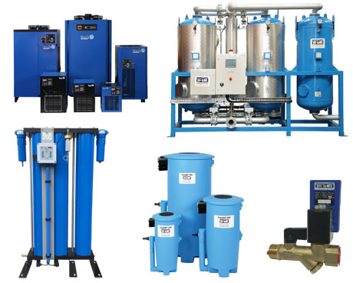
Compressed air purification equipment from Hi-line Industries can provide compressed air to ISO 8573.1:2010 quality standards.
Download high resolution 300dpi image
Download low resolution 72dpi image

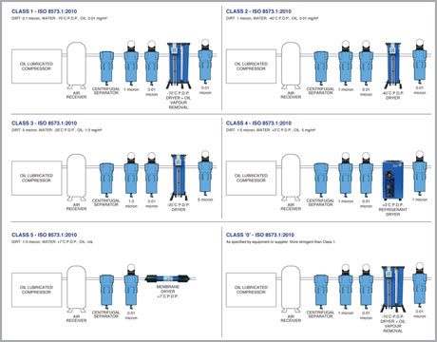
In conjunction with BCAS, Hi-line Industries have produced a best practice guide for the filtration and drying of compressed air.
Download high resolution 300dpi image
Download low resolution 72dpi image

Continued ……

Whenever the purity of compressed air required is specified then the ISO standard must be referenced and then the class for each contaminant (Dirt/Water/Oil) is listed in turn.
Download high resolution 300dpi image
Download low resolution 72dpi image

END

