PRESS RELEASE HLI58

COMPLETE RELIABILITY AND LOWEST RUNNING COSTS
WITH 2018 TUNDRA AIR DRYERS

Hi-line Industries, an established and reputable UK manufacturer of high-quality compressed air purification equipment, has made a number of enhancements to its already class-leading Tundra range of refrigeration dryers. Thanks to an impeccable reliability rate, with zero failures from hundreds of models already sold, the 2018 series is offered with a new two-year warranty. Moreover, the latest dryers provide the lowest possible running costs and increased flow via a new Hi-Flo heat exchanger with larger ports.

Already long-established as the UK’s market-leading refrigerant air dryer, the 2018 Tundra range is Hi-line’s most energy efficient to date, with a robust and high quality build standard. Minimal energy consumption is crucial in today’s competitive environment and the new Tundra dryer from Hi-line will help drive down energy costs by minimising pressure drop and lowering absorbed power.

Among many proprietary innovations, Hi-line’s integral Direct Expansion technology offers a constant +3°C dewpoint at all times, unlike chilled mass dryers, which can be as high as +10°C during their thermal cycle. Furthermore, the new and improved single-cell, all-aluminium heat exchanger module gives the most efficient transfer of heat at the lowest energy cost.

Another important energy-saving features of the latest Tundra dryers is the variable-speed fan, which ensures only the required amount of energy is consumed. Moreover, by controlling the fan speed on the refrigerant circuit, Hi-line has been able to eliminate components such as fan-pressure switches, which can often become defective in this type of dryer. The fewer moving parts, the more reliable the product.
Continued ……

Continuing the low-energy, high-reliability theme, 2018 Tundra dryers are built with Scroll refrigerant Freon compressors, which offer the lowest possible power consumption and deliver a cost-effective, long-life performance. With reliability at the forefront, Tundra 2018 models offer multiple new design features to ensure constant dewpoint at all load levels and deliver continuous dry-air performance that satisfies ISO 7183 industry standards.

Another benefit of Tundra refrigeration dryers sees the microprocessor-based multifunctional controller linked to the condensate removal valve, thus minimising any loss of compressed air as the condensate is discharged. Full programmability ensures settings can be adjusted to suit climatic conditions. The 2018 Tundra also has the option of Hi-line’s ZLD zero-loss auto drain, which is designed to eliminate accumulated contaminants from pressurised air systems. ZLD drains incorporate a level control that ensures zero air loss during the condensate discharge process.

Tundra refrigeration air dryers are proven in applications such as workshop air and machine air in general manufacturing, as well as further uses in sectors that include packaging, textile, food, beverage, medical, dairy and automotive. Dryer selection is based on factors such as maximum compressed air flow, lowest operating pressure, maximum ambient air temperature and maximum air inlet temperature. Hi-line’s applications team can help apply a corrected capacity formula to ensure the optimum dryer is selected.

The 2018 Tundra series comprises 16 models spanning compressed air flows from 22 to 1700 cfm (37 to 2888 m3/hr) and operating pressure from 4 to 16 barg. Maximum inlet air temperature is +60°C, with ambient air temperature up to +50°C. High pressure (up to 50 barg) and thermal mass versions can be ordered. Hi-line’s standard range is available ex-stock at from the company’s Burton factory for next-day delivery, with larger dryers up to 9988 cfm available on short lead-times.

Continued ……
Further information is available from: Hi-line Industries Ltd,
5 Crown Industrial Estate, Oxford Street, Burton on Trent, Staffordshire DE14 3PG
Telephone: 01283 533377 Fax: 01283 533367
e-mail: enquiries@hilineindustries.com www.hilineindustries.com

(approximately 610 words
including photographic annotation)
General Information

Supplier: Hi-line Industries Ltd

Press Release No: HLI58

Press or publishing inquiries to: Steve Lloyd
Enterprise Marketing Services Ltd
The Coach House, 1 Dunstall Road, Barton under Needwood,
Burton on Trent, Staffordshire, DE13 8AX, UK
Tel: +44 (0) 1283 713185
Fax: +44 (0) 1283 716172
E-mail: info@enterprise-marketing.co.uk

Reader response inquiries to: Mr Steven D Smith
Sales & Marketing Director of Hi-line Industries Ltd

Downloads: The press release text (MS Word and PDF format) and image are
available for download at:

www.enterprise-marketing.co.uk/hli/hli58.html

Our Reference: HLI58/18/02/V2

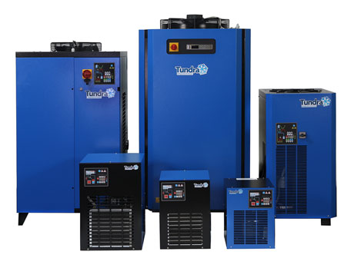
The new Tundra air dryers from Hi-line Industries Ltd, offering the highest ever rates of reliability with the lowest possible running costs.
Download high resolution 300dpi image
Download low resolution 72dpi image
END

