PRESS RELEASE HLI57

LATEST HI-LINE COMPRESSED AIR DRAINS
OFFER BOTH VALUE AND PERFORMANCE

Hi-line Industries, an established and reputable UK manufacturer of high-quality compressed air purification equipment, has launched its new HTD condensate drain into the UK market. Featuring an isolation valve for strainer cleaning to 250 micron, the latest-generation HTD offers a 100% ED rated solenoid coil and multi-voltage timer controller to ensure automatic compressed air system drainage.

Although condensate drains are possibly the most inconspicuous components in a compressed air system, they are among the most important. These compact yet innovative products have to function with extreme reliability for the system’s filters and separators to do their job effectively. Moreover, compressed air drains prevent moisture carry-over, which can wash away lubricant on motors and bearings found in tools and machinery, leading to premature wear, higher maintenance and greater expense.

Hi-line’s HTD is a fully automatic (no maintenance) drain offering a high performance-to-cost ratio. Described as Britain’s best value autodrain, the HTD is based on a high-quality, 16-bar rated brass valve body which is precision machined to fine tolerances. High pressure variants at 40 and 80 bar are also available to order. The valve orifice bore is 4mm in diameter, thus allowing the largest piece of dirt, metal or scale to be removed along with the condensate.

At either end of the 2/2 way direct-acting valve can be found a ½” male and ½” BSP female connection. The coil is available in 24, 100 and 240V versions, and is 100% ED rated to offer long service life and facilitate operation in temperatures up to 60˚C.
Continued ……

To allow use across the full range of Hi-line drains, the solid-state timer controller is multi voltage. Furthermore, the rugged ABS housing/enclosure is IP65 rated to reflect its suitability for use in harsh operating environments. LED indicators display the operational status of the drain, while a manual test button is also employed.

Timer drains such as the HTD are a popular option based on cost, ease of installation and reliability, particularly if fitted with a strainer on the inlet. Designed for use on filter housings, after coolers, dryers, pressure vessels, air receivers and compressors, regardless of size or capacity, the adjustable interval times (30 seconds to 45 minutes) and discharge times (0.5 to 10 seconds) allow users to make the drain to work at its optimum and become energy efficient.

Further information is available from: Hi-line Industries Ltd,
5 Crown Industrial Estate, Oxford Street, Burton on Trent, Staffordshire DE14 3PG
Telephone: 01283 533377 Fax: 01283 533367
e-mail: enquiries@hilineindustries.com www.hilineindustries.com

(approximately 410 words
including photographic annotation)

General Information

Supplier: Hi-line Industries Ltd

Press Release No: HLI57

Press or publishing inquiries to: Steve Lloyd
Enterprise Marketing Services Ltd
The Coach House, 1 Dunstall Road, Barton under Needwood,
Burton on Trent, Staffordshire, DE13 8AX, UK
Tel: +44 (0) 1283 713185
Fax: +44 (0) 1283 716172
E-mail: info@enterprise-marketing.co.uk

Reader response inquiries to: Mr Steven D Smith
Sales & Marketing Director of Hi-line Industries Ltd

Downloads: The press release text (MS Word and PDF format) and image are
available for download at:
www.enterprise-marketing.co.uk/hli/hli57.html

Our Reference: HLI57/17/11/V2

Continued ……
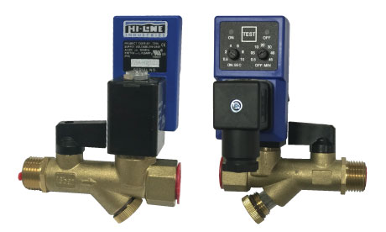
The new HTD fully automatic condensate drain from Hi-line Industries, offering high performance-to-cost ratio.
Download high resolution 300dpi image
Download low resolution 72dpi image

END

