PRESS RELEASE HLI56

LATEST HI-LINE AIR DRYERS OFFER EVEN MORE BENEFITS

Hi-line Industries, an established and reputable UK manufacturer of high-quality compressed air purification equipment, has unveiled the latest generation of its flagship HBP-ZL absorption air dryers. Featuring a long list of enhancements, these already best-selling air dryers now offer even more appeal to those in the manufacturing and process industries.

With the latest upgrade, Hi-line can now place more emphasis on meeting specific customer requirements. For instance, although the new-generation HBP-ZL absorption air dryers feature a high-quality Siemens touch-screen controller as standard, Hi-line can install whatever controller the customer desires. This flexibility in terms of choice is extended further through the availability of TÜV and PED or ASME 8 vessels, along with stainless steel or galvanised pipework options. For OEM customers, the system can even be branded to suit compressor equipment, if required.

Hi-line has also focussed on minimising TCO (total cost of ownership) with the latest generation systems. Energy consumption is one of the primary contributors to TCO, which is why HBP-ZL equipment offers the lowest possible running costs of any similar dryer, principally through constant automatic fine tuning of its innovative AEMS – Automatic Energy Management System.

AEMS, which is fitted as standard, undertakes continuous data collection from the dryer operation to maintain cost-effective timing and utilisation of the drying cycles. Moreover, the process can be optimised with precise appropriation of low-energy tariffs for the selection of heater regeneration cycles. Importantly, no compressed air is lost or wasted during operation and system regeneration is achieved by desiccant cooling together with an external heat source and bi-directional blower.
Continued ……

The unit is fully lagged as standard to enhance efficiency even further, while electric, steam, heat of recovery and solar regeneration options can be offered. Additional energy saving functionality includes soft-start options and the deployment of bi-directional fans in tandem with integral data logging functions for the AEMS. Dial-in modems and Bluetooth facilities are also available.

Quality is assured with the UK-designed and assembled HBP-ZL. Failsafe, top quality stainless steel valves and actuators are used throughout, along with stainless steel wedge wire air-diffuser plates. UK-manufactured components are used wherever possible, and a 10-year warranty is available to all customers that take out a service contract.

The range of standard dryers spans 15 models that provide throughput capacities from 165 up to 5500 scfm. An on-site survey can be undertaken determine dryer height and footprint dimensions, as well as any alternative software requirements. Build times are the shortest in the industry as appropriate vessels are held in stock.

Hi-line fully supports its products using the company’s nationwide team of service technicians, each of whom is fully trained and conversant with energy management and compressed air requirements.

Further information is available from: Hi-line Industries Ltd,
5 Crown Industrial Estate, Oxford Street, Burton on Trent, Staffordshire DE14 3PG
Telephone: 01283 533377 Fax: 01283 533367
e-mail: enquiries@hilineindustries.com www.hilineindustries.com

(approximately 500 words
including photographic annotation)

Continued ……
General Information

Supplier: Hi-line Industries Ltd

Press Release No: HLI56

Press or publishing inquiries to: Steve Lloyd
Enterprise Marketing Services Ltd
The Coach House, 1 Dunstall Road, Barton under Needwood,
Burton on Trent, Staffordshire, DE13 8AX, UK
Tel: +44 (0) 1283 713185
Fax: +44 (0) 1283 716172
E-mail: info@enterprise-marketing.co.uk

Reader response inquiries to: Mr Steven D Smith
Sales & Marketing Director of Hi-line Industries Ltd

Downloads: The press release text (MS Word and PDF format) and image are
available for download at:

www.enterprise-marketing.co.uk/hli/hli56.html

Our Reference: HLI56/17/09/V1

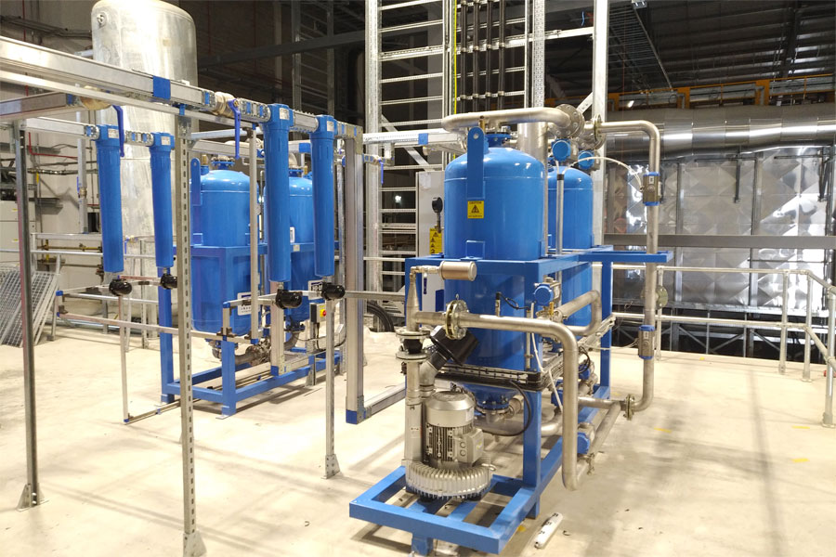
The latest generation of HBP-ZL absorption air dryers from Hi-line Industries feature many enhancements, including improved energy consumption.
Download high resolution 300dpi image
Download low resolution 72dpi image

END

