PRESS RELEASE HLI55

NEW NATIONAL DISTRIBUTION MANAGER
FOR HI-LINE INDUSTRIES

Hi-line Industries, UK manufacturer of high-quality, energy efficient, compressed air purification equipment, have appointed Damien Oxlee as their new National Distribution Manager. Damien joins the company at a time of strength as the company continues to grow year on year with record turnover for their previous financial year.

Damien has a wealth of experience within the engineering industry having been Group Sales Manager at Western Business Publishing since 2010, working on titles such as Air User and Industrial Plant & Equipment. Prior to that, he worked as Publication Manager at Datateam Publishing for six years and has known and worked alongside Hi-line for many years in his previous publishing roles.

Damien is married with two children and will look after Hi-line’s interests throughout England and Wales. Amongst his many hobbies are sports cars, food, golf, football, travel and cycling including recently riding to Amsterdam from Kent raising money for Demelza Hospice Care for Children.

A member of the British Compressed Air Society and carrying ISO 9001:2008 certification, Hi-line’s UK headquarters are situated in Burton-upon-Trent where they manufacture some of the most energy-efficient compressed air dryers in the world as well as bespoke and ‘off the shelf’ heat regeneration zero loss adsorption dryers. Their products are used throughout industry and general manufacturing including areas such as medical, dairy, textile, breathing air, packaging and the automotive sector. The company’s Nitrogen and Oxygen O2 generators are recognised as the best value for money in the UK food and beverage industry.
Continued ……

Hi-line are proud to be part of the "Made in Britain" campaign promoting the best of British manufacturing, and has built up an enviable reputation for the innovative design, manufacture and supply of their compressed air purification equipment. All Hi-line products are designed and built to the highest standards of quality by experienced and qualified engineers, while their service department employ some of the most experienced compressed air treatment service personnel in the industry, together with engineers trained in all aspects of compressed air and gas generation.

Further information is available from: Hi-line Industries Ltd,
5 Crown Industrial Estate, Oxford Street, Burton on Trent, Staffordshire DE14 3PG
Telephone: 01283 533377 Fax: 01283 533367
e-mail: enquiries@hilineindustries.com www.hilineindustries.com

(approximately 380 words
including photographic annotation)

General Information

Supplier: Hi-line Industries Ltd

Press Release No: HLI55

Press or publishing inquiries to: Steve Lloyd
Enterprise Marketing Services Ltd
The Coach House, 1 Dunstall Road, Barton under Needwood,
Burton on Trent, Staffordshire, DE13 8AX, UK
Tel: +44 (0) 1283 713185
Fax: +44 (0) 1283 716172
E-mail: info@enterprise-marketing.co.uk

Reader response inquiries to: Mr Steven D Smith
Sales & Marketing Director of Hi-line Industries Ltd

Downloads: The press release text (MS Word and PDF format) and image are
available for download at:

www.enterprise-marketing.co.uk/hli/hli55.html

Our Reference: HLI55/17/07/V2

Continued ……
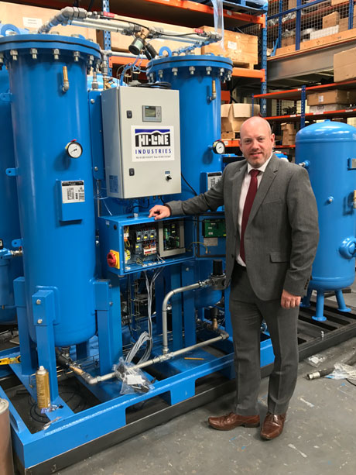
Damien Oxlee who is joining the Hi-line Industries team as National Distribution Manager.
Download high resolution 300dpi image
Download low resolution 72dpi image

END

