PRESS RELEASE HLI54

ULTRA-HIGH FLOW HEAT EXCHANGER AMONG
ENHANCEMENTS TO 2017 TUNDRA AIR DRYER RANGE

Hi-line Industries, an established and reputable UK manufacturer of high-quality compressed air purification equipment, has unveiled its latest-generation Tundra range of refrigeration air dryers. Designed to serve a host of potential users, including workshop air and machine air in general manufacturing, as well as sectors such as packaging, textile, food, beverage, medical, dairy and automotive, Tundra 2017 air dryers feature a number of important enhancements. These include an ultra-high flow heat exchanger with larger ports and an ‘ice blue’ digital LED dewpoint display. New capacity models are also introduced to the range.

With many manufacturers now actively attacking overheads in order to remain competitive, energy efficiency was among the principal priorities when developing Hi-line’s 2017 Tundra series. Tundra dryers help drive energy costs down by minimising pressure drop and reducing absorbed power. Furthermore, integrated direct expansion technology delivers a constant +3°C PDP (pressure dewpoint), unlike a chilled mass dryer, which can be as high as +10°C during its thermal cycle. As a result, Hi-line’s new single-cell aluminium heat exchanger module (with larger ports) provides the most efficient transfer of heat at the lowest energy cost.

In the heat exchanger, incoming air is pre-cooled and outgoing air is post-heated. This allows a reduction in energy consumption of the chiller circuit and reduces the possibility of condensate forming on the outer surface of the pipe exiting the dryer.

Continued ……

A further innovation of the 2017 Tundra series references the energy-saving controller, which now features the ‘ice blue’ digital LED dewpoint display as standard on all models. This means that when the dryer goes on to light duty (reduced airflow), refrigerant gas levels are monitored and adjusted automatically. The dryer features an integrated control feature that will stop the Freon compressor and wait for the refrigerant gas pressure to rise to a preset value before starting up again, thus minimising energy consumption.

The 2017 Tundra series comprises 16 models spanning compressed air flows from 21 to 1605 cfm (36 to 2720 m3/hr) and operating pressure from 4 to 16 barg. Maximum inlet air temperature is +60°C, with ambient air temperature from 0 to +50°C. Three new capacities, 110, 179 and 1400 are introduced for the first time, replacing the former 120, 159 and 1330 models. High pressure (up to 50 barg) and thermal mass versions are also available to order.

Dryer selection is based on factors such as maximum compressed air flow, lowest operating pressure, maximum ambient air temperature and maximum air inlet temperature. Hi-line’s applications team can help apply a corrected capacity formula to ensure the optimum dryer is selected.

Just like previous-generation Tundra systems, reliability is assured through the use of proven, high-quality components, such as the flow mixing chamber, evaporator and demister. Also featured within the refrigerant system are liquid receivers, line dryers, thermostatic expansion valves and a series of safety devices designed to protect the Freon compressor and its components.

Larger dryers within the new range are available on short lead-times, although most of the standard range is available ex-stock from Hi-line’s Burton-on-Trent factory ready for next-day delivery. Options include zero loss or HTD (Hi-line Timer Drain) condensate removal, while a selection of high-performance oil and particulate filters is also available.

Continued ……
Further information is available from: Hi-line Industries Ltd,
5 Crown Industrial Estate, Oxford Street, Burton on Trent, Staffordshire DE14 3PG
Telephone: 01283 533377 Fax: 01283 533367
e-mail: enquiries@hilineindustries.com www.hilineindustries.com

(approximately 610 words
including photographic annotations)

General Information

Supplier: Hi-line Industries Ltd

Press Release No: HLI54

Press or publishing inquiries to: Steve Lloyd
Enterprise Marketing Services Ltd
The Coach House, 1 Dunstall Road, Barton under Needwood,
Burton on Trent, Staffordshire, DE13 8AX, UK
Tel: +44 (0) 1283 713185
Fax: +44 (0) 1283 716172
E-mail: info@enterprise-marketing.co.uk

Reader response inquiries to: Mr Steven D Smith
Sales & Marketing Director of Hi-line Industries Ltd

Downloads: The press release text (MS Word and PDF format) and images are
available for download at:

www.enterprise-marketing.co.uk/hli/hli54.html

Our Reference: HLI54/17/06/V2

Continued ……

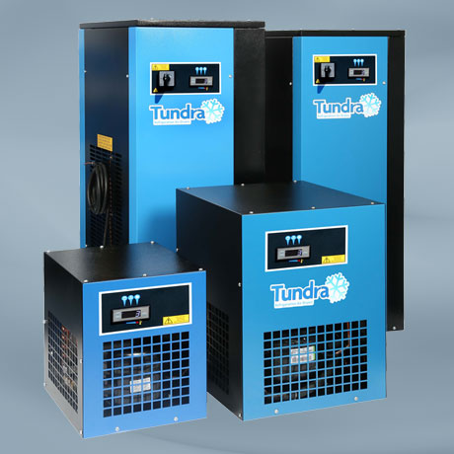
The latest 2017 model of Tundra air dryers from Hi-line industries featuring a new ultra-high flow heat exchanger with larger ports.
Download high resolution 300dpi image
Download low resolution 72dpi image

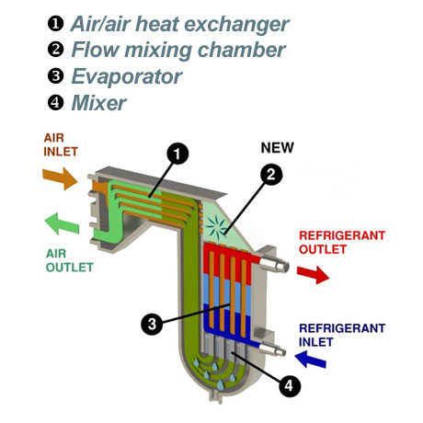
The Hi-Flo larger port all aluminium heat exchanger which incorporates a new flow mixing chamber.
Download high resolution 300dpi image
Download low resolution 72dpi image

END

