PRESS RELEASE HLI53

HI-LINE FREEZES PRICES FOR SEVENTH YEAR

Hi-line Industries, an established and reputable UK manufacturer of high quality compressed air purification equipment, has announced that customer prices are to remain frozen for the seventh consecutive year. The company says it can do this thanks to greater product turnover and increased access to better prices as a result of rising year-on-year spend.

In a time full of uncertainty, Hi-line wants to let the marketplace know that some things remain clear and guaranteed. The fact that the company’s energy-efficient compressed air equipment, which includes air dryers, nitrogen and oxygen generators, compressed air filtration equipment, condensate management/drains and service kits, has been available at the same price for the past seven years is a shot in the arm for customers in industries such as food, beverage, medical, general manufacturing, dairy, automotive and laser cutting.

Hi-line’s strong market performance in recent years is a major contributory factor in the decision to freeze prices once more. For instance, at the company’s year-end in July, turnover stood at a record level, with the order book continuing to swell in the period since.

Formed in 1999, Hi-line has expanded year-on-year, posting steady double-digit growth. Moreover, the demand for British-manufactured goods since the Brexit vote is unprecedented. In tandem with a weaker pound against the euro, Hi-line has performed impressively in the export market, although the UK is also proving strong, with an increasing number of national brands trying to support other manufacturers by placing orders in Britain.

Continued ……

A further factor behind Hi-line’s ability to ensure prices remain unchanged is its good relationship with trusted suppliers. The company is part of the Made in Britain campaign and, whenever possible, opts to source wholly British materials to manufacture their flagship compressed air purification equipment.

Hi-line is a member of the British Compressed Air Society, carries ISO 9001:2008 certification and makes some of the most energy-efficient compressed air dryers in the world. The company is also Britain’s largest stockist of a broad range of air treatment ancillaries – and the country’s largest supplier of refrigeration air dryers. As a result of its success, Hi-line recruited strongly in December and January to help cope with increasing demand for its products and services.

Further information is available from: Hi-line Industries Ltd,
5 Crown Industrial Estate, Oxford Street, Burton on Trent, Staffordshire DE14 3PG
Telephone: 01283 533377 Fax: 01283 533367
e-mail: enquiries@hilineindustries.com www.hilineindustries.com

(approximately 440 words
including photographic annotations)

General Information

Supplier: Hi-line Industries Ltd

Press Release No: HLI53

Press or publishing inquiries to: Steve Lloyd
Enterprise Marketing Services Ltd
The Coach House, 1 Dunstall Road, Barton under Needwood,
Burton on Trent, Staffordshire, DE13 8AX, UK
Tel: +44 (0) 1283 713185
Fax: +44 (0) 1283 716172
E-mail: info@enterprise-marketing.co.uk

Reader response inquiries to: Mr Steven D Smith
Sales & Marketing Director of Hi-line Industries Ltd

Downloads: The press release text (MS Word and PDF format) and images are
available for download at:

www.enterprise-marketing.co.uk/hli/hli53.html

Our Reference: HLI53/17/03/V2

Continued ……
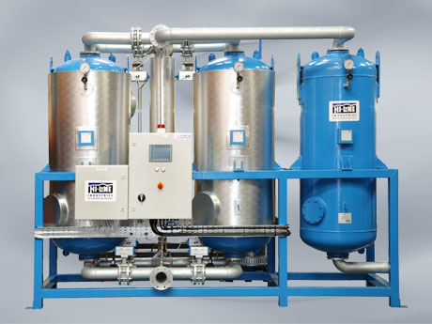
Typical air dryer from Hi-line Industries, just one of their compressed air purification products with prices frozen for the seventh consecutive year.
Download high resolution 300dpi image
Download low resolution 72dpi image

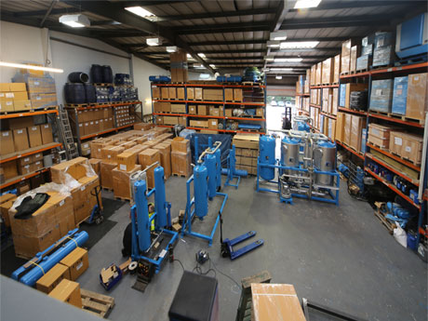
The Hi-line Industries factory in Burton on Trent where British materials are used to manufacture their flagship compressed air purification equipment.
Download high resolution 300dpi image
Download low resolution 72dpi image

END

