PRESS RELEASE HLI52

ZERO-LOSS DESICCANT AIR DRYERS
WITH PROVEN PERFORMANCE & RELIABILITY

The HBP-ZL flagship range of adsorption air dryers manufactured by air treatment specialists Hi-line Industries Ltd combine reliability, performance and economical operation. These versatile products are being utilised throughout manufacturing and processing industries, with particular successes being achieved within food related markets. With this range, which was introduced some 15 years ago, longevity of the products has also become an established factor.

A dewpoint of -70°C can be maintained with these air purification products, while also ensuring a zero loss of any processed compressed-air. The lowest possible operational and ownership costs are achieved by continually recording the equipment working parameters, and providing feedback to the equipment control unit. This information is continually processed to achieve a consistent, optimum dryer performance. The utilisation of high quality Rockwall lagging, combined with thermally efficient heaters, ensures that the HPB models generously sized dryer vessels maintain a high proportion of their operational duty in an economic standby mode. Further energy saving features include soft start options and the use of bi-directional fans coupled with built-in data logging functions for the AEMS (Automated Energy Management System) available via USB port extraction. Dial-in modems and Bluetooth facilities are also available.

Continued ……

The AEMS system undertakes continuous data collection from the dryer operation to maintain cost effective optimum timing and utilisation of the drying cycles. This process can be optimised with precise appropriation of low-energy tariffs for selection of heater regeneration cycles. No compressed air is lost or wasted during operation and the system regeneration is achieved by desiccant cooling together with an external heat source and bi-directional blower. Viable heat regeneration sources include electrical, oil, steam and heat of recovery and dual-heat, or whatever source is most locally available.

The range of standard dryers covers 15 models providing throughput capacities from 165 up to 5500 scfm. The physical requirements of dryer height and footprint dimensions, as well as alternative software requirements can all be established, even including customer colour choice, during “on-site” survey.

Siemens PLC control is available as standard with optional Mitsubishi or Allen Bradley systems available on request. Pressure vessels conform to BS EN 5500 and ASME VIII plus PED (Pressure Equipment Directive) 97/23EC. Stainless steel interconnecting pipework and valves are utilised throughout. Maintenance agreements are also available which automatically extend the product warranty period to five years.

All Hi-line products are fully supported by their nationwide team of service technicians, fully trained and conversant with energy management and compressed air requirements.

Further information is available from: Hi-line Industries Ltd,
5 Crown Industrial Estate, Oxford Street, Burton on Trent, Staffordshire DE14 3PG
Telephone: 01283 533377 Fax: 01283 533367
e-mail: enquiries@hilineindustries.com www.hilineindustries.com

(approximately 450 words
including photographic annotations)

Continued ……
General Information

Supplier: Hi-line Industries Ltd

Press Release No: HLI52

Press or publishing inquiries to: Steve Lloyd
Enterprise Marketing Services Ltd
The Coach House, 1 Dunstall Road, Barton under Needwood,
Burton on Trent, Staffordshire, DE13 8AX, UK
Tel: +44 (0) 1283 713185
Fax: +44 (0) 1283 716172
E-mail: info@enterprise-marketing.co.uk

Reader response inquiries to: Mr Steven D Smith
Sales & Marketing Director of Hi-line Industries Ltd

Downloads: The press release text (MS Word and PDF format) and images are
available for download at:

www.enterprise-marketing.co.uk/hli/hli52.html

Our Reference: HLI52/17/01/V2

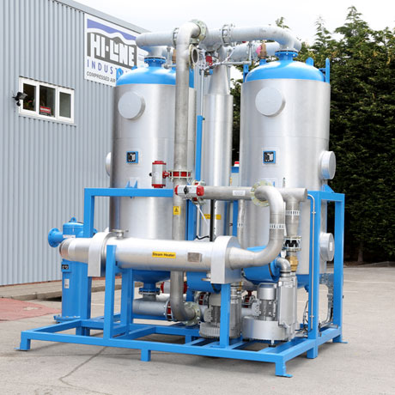
One of the HBP-ZL blower programme models from Hi-line Industries Ltd, which feature zero-loss desiccant during their automated drying programme.
Download high resolution 300dpi image
Download low resolution 72dpi image

Continued ……
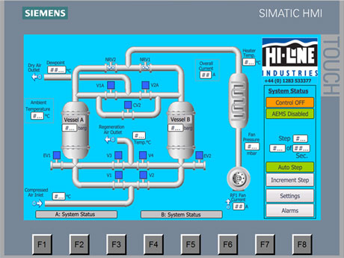
Touch screen interface on the Hi-line HBP-ZL desiccant air dryers which incorporate an Automatic Energy Management System for maximum operating efficiency.
Download high resolution 300dpi image
Download low resolution 72dpi image

END

