PRESS RELEASE HLI51

HI-LINE SEES ORDERS SOAR POST BREXIT VOTE

Hi-line industries, an established and reputable UK manufacturer of high quality compressed air handling and purification equipment is reporting its most successful period ever following the Brexit referendum vote earlier this year. In fact, at the company’s year-end in July, Hi-line’s turnover grew at a record 28%. Furthermore, with its new financial year beginning in the summer period, orders have continued to increase at strong levels particularly on large projects.

Since its inception in 1999, Hi-line has expanded year-on-year, enjoying steady double-digit growth. However, the surge in demand for British-manufactured goods since the Brexit vote is unprecedented. Together with a weakening of the pound against the euro, this has stood Hi-line well in the export market. In contrast, competitors in countries like Germany, which is traditionally strong in compressor technologies, are finding it tougher.

Hi-line is witnessing a growing number of companies in Europe using the currency fluctuations to their advantage by buying British. However, from the UK too, there is growing demand with an increasing number of British brands trying to support other national manufacturers by placing orders in the UK.

The company is part of the Made in Britain campaign and, wherever possible, also chooses to source wholly British materials to build its flagship compressed air purification equipment. As a result, following a strong recruitment drive in December, Hi-line is taking on more engineers and office staff in January to help with the increased demand for their air dryers, adsorption dryers, nitrogen/oxygen generators, filtration equipment and condensate management technologies that 2017 will bring.

Continued ……

Hi-line’s UK headquarters are situated in Burton-upon-Trent, a traditional brewery town in the heart of the UK with great transport links. In fact, Hi-line supplies a lot of compressed air purification technologies to breweries in Burton and the rest of the country, from micro-breweries to international operations.

Hi-line makes some of the most energy-efficient compressed air dryers in the world, and has an enviable reputation for manufacturing the most energy-efficient range of bespoke and ‘off the shelf’ heat regeneration zero loss adsorption dryers. Furthermore, the company’s N2 and O2 generators are recognised as the best value for money in the UK food and beverage industry.

A member of the British Compressed Air Society and carrying ISO 9001:2008 certification, Hi-line has further established their reputation for the innovative design, manufacture, supply and installation of energy-efficient compressed air purification equipment. As Britain’s largest stockist of a broad range of air treatment ancillaries – and largest supplier of refrigeration air dryers – the company’s products are designed and built to the highest standards of quality by experienced and qualified engineers.

Utilising the latest 3D CAD software design tools, alongside ongoing investment in staff training, Hi-line has both the technology and expertise to develop innovative products. In fact, such is the company’s confidence in its high quality workmanship and materials that a five year warranty is offered.

Hi-line also offers a nationwide service department, managing the compressed air requirements of customers across the UK so that they can concentrate on their core business. The service department boasts some of the country’s most experienced compressed air treatment service personnel, all of whom are ACRIB-registered engineers trained in all aspects of compressed air and gas generation.

Continued ……

Further information is available from: Hi-line Industries Ltd,
5 Crown Industrial Estate, Oxford Street, Burton on Trent, Staffordshire DE14 3PG
Telephone: 01283 533377 Fax: 01283 533367
e-mail: enquiries@hilineindustries.com www.hilineindustries.com

(approximately 640 words
including photographic annotations)

General Information

Supplier: Hi-line Industries Ltd

Press Release No: HLI51

Press or publishing inquiries to: Steve Lloyd
Enterprise Marketing Services Ltd
The Coach House, 1 Dunstall Road, Barton under Needwood,
Burton on Trent, Staffordshire, DE13 8AX, UK
Tel: +44 (0) 1283 713185
Fax: +44 (0) 1283 716172
E-mail: info@enterprise-marketing.co.uk

Reader response inquiries to: Mr Steven D Smith
Sales & Marketing Director of Hi-line Industries Ltd

Downloads: The press release text (MS Word and PDF format) and images are
available for download at:

www.enterprise-marketing.co.uk/hli/hli51.html

Our Reference: HLI51/16/12/V2

Continued ……
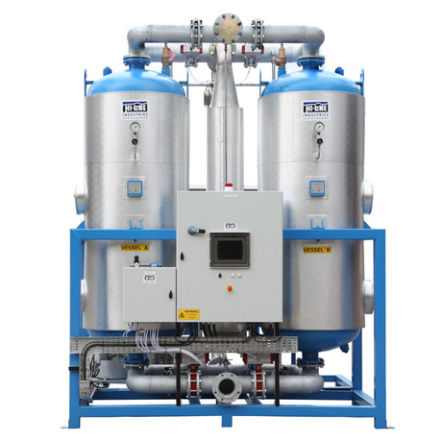
Front view of the Hi-line HBP-ZL zero loss desiccant air dryer, part of their blower programme providing maximum operating efficiency.
Download high resolution 300dpi image
Download low resolution 72dpi image

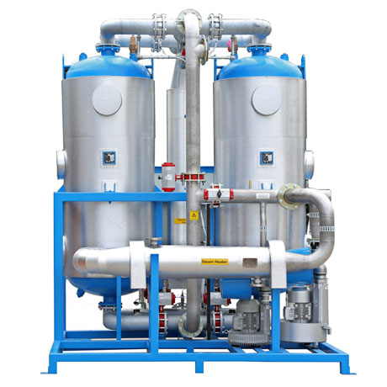
Rear view of the HBP-ZL air dryer from Hi-line Industries, offering -70°C dewpoint without any compressed air loss.
Download high resolution 300dpi image
Download low resolution 72dpi image

Continued ……
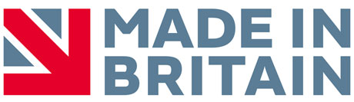
Hi-line are part of the Made in Britain campaign and, wherever possible, also chooses to source wholly British materials to build its compressed air purification equipment.
Download high resolution 300dpi image
Download low resolution 72dpi image

END

