PRESS RELEASE HLI50

ON-SITE N₂/0₂ GENERATION SAVES THOUSANDS IN
COMPARISON WITH TYPICAL OUTSOURCING COSTS

Offering the ideal solution for any plant looking to eliminate the financial burden of buying-in nitrogen and/or oxygen, the latest N₂ and O₂ high purity, low energy nitrogen and oxygen generators from Hi-line Industries feature a host of advanced functions, including O₂ analysers and energy control as standard. The generators are the perfect answer to companies spending thousands of pounds annually purchasing bottled or bulk tanks of the planet’s most abundant gasses. In contrast, the potential savings available by producing nitrogen and oxygen on-site, on-demand, are little short of staggering, even more so when including the extra costs associated with delivery, storage, the hire of bottles or receivers, safety procedure creation, and insurance.

The proven technology employed at Hi-line for N₂/O₂ generation is based on simple PSA (Pressure Swing Adsorption) procedures. Here, twin-tower CMS (carbon molecular sieve) beds adsorb and regenerate to remove either N₂ or O₂ depending on requirements. Importantly, this allows users to generate nitrogen at the purity required for the application, such as 95% or 98% for example. This is far more cost-effective than buying-in expensive UHP (Ultra High Purity) nitrogen at 99.99999%, which is normally sold as standard without any option for the customer.

Among the many areas where the uptake of Hi-line’s N₂/O₂ generators has been particularly high is MAP (Modified Atmosphere Packaging), a technique used for prolonging the shelf life of fresh or minimally-processed foods such as meat, fish, cheese, fruits and vegetables. The mixture of gases in the package depends on the type of product, packaging materials and storage temperature.

Continued ……

A recent case in point can be seen at a well-known food packaging company that was spending in excess of £120,000 per annum on N₂ for MAP. Moreover, this was excluding the delivery charges associated with a tanker arriving at the plant four times a week. In response, Hi-line was able to supply a N₂ generator skid for a one-off fee of £55,000. Now, the plant produces its own N₂ for only the cost of air compressor energy; a huge saving year-on-year.

Nitrogen gas is commonly used in a wide range of industries where safe, inert environments are required. This includes the petroleum, chemical, pharmaceutical, paint and varnish industries as well as the production of ferrous and non-ferrous metals, together with electronic and glass products.

Although Hi-line offers a standard range of generators for N₂/O₂, each generator is customised in line with user requirements. Before a generator is manufactured, Hi-line will have already carried out a free site survey of N₂/O₂ usage, and at what rate/purity. The team will also assess energy costs versus the current cost of gas and present a proposal indicating the potential savings available. This will include total cost of ownership, which is very low as the only relevant energy source used by the generator is the air compressor. Ultimately, Hi-line generation units are designed to facilitate rapid payback, thanks to the significant cost savings that can be achieved.

Further information is available from: Hi-line Industries Ltd,
5 Crown Industrial Estate, Oxford Street, Burton on Trent, Staffordshire DE14 3PG
Telephone: 01283 533377 Fax: 01283 533367
e-mail: enquiries@hilineindustries.com www.hilineindustries.com

(approximately 560 words
including photographic annotations)

Continued ……
General Information

Supplier: Hi-line Industries Ltd

Press Release No: HLI50

Press or publishing inquiries to: Steve Lloyd
Enterprise Marketing Services Ltd
The Coach House, 1 Dunstall Road, Barton under Needwood,
Burton on Trent, Staffordshire, DE13 8AX, UK
Tel: +44 (0) 1283 713185
Fax: +44 (0) 1283 716172
E-mail: info@enterprise-marketing.co.uk

Reader response inquiries to: Mr Steven D Smith
Sales & Marketing Director of Hi-line Industries Ltd

Downloads: The press release text (MS Word and PDF format) and images are
available for download at:

www.enterprise-marketing.co.uk/hli/hli50.html

Our Reference: HLI50/16/10/V2

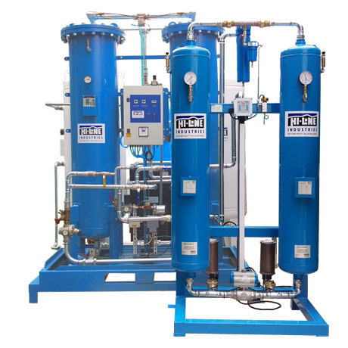
Economical O₂ generator from Hi-line Industries Ltd, incorporating their PSA (Pressure Swing Adsorption) operating principle.
Download high resolution 300dpi image
Download low resolution 72dpi image

Continued ……
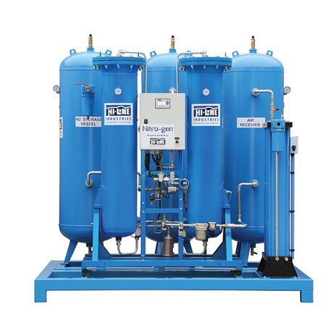
Nitrogen generator, available from Hi-line Industries Ltd, for economic N₂ generation.
Download high resolution 300dpi image
Download low resolution 72dpi image

END

