PRESS RELEASE HLI49

HI-LINE CONDENSATE CLEANERS
ENSURE FULL LEGAL COMPLIANCE
The ConSEP range of oil/water compressor condensate cleaners, manufactured by Hi-line Industries Ltd, offer not only a very compact and efficient way of dealing with compressor condensate, but these products are also fully compliant with the ‘1991 Water Resources Act’.

During the compression process air is compressed to typically 7 bar, which provides an eight fold greater water loading than conventional air at normal atmospheric pressures. This additional moisture is then also processed out to become condensate from the dryers and filters, but this condensate also contains droplets from the compressor oil, which together cause a toxic cocktail.

However, the Hi-line ConSEP range of condensate cleaners treat the condensate with flocculants and activated carbon in an adsorption phase. This purifies the condensate, so providing a clean water solution which is clean enough to supersede local water authority regulations which stipulate a contaminant content of less than 5mg/litre.

Air handling specialists Hi-line Industries have recently developed this process, which is a new concept in the treatment of compressor condensate discharge. Their latest ConSEP products also provide a 10% higher volumetric capacity than their previous Gen 2 range, enabling the utilisation of greater oleophilic as well as superior activated carbon filtration media. The increased service life achieved by these products is also backed-up by this established midlands manufacturer, providing a lifetime warranty against leaks or product malfunctions.

Continued ……

Current UK and European consent levels are exceeded by the ConSEP range, which is compatible with all current condensate drains as well as many types of oils. Moving parts, along with both static water and oil containers have been eliminated to ensure the new larger and stronger ConSEP provides a simple, reliable and friendly environmental solution for the economical treatment of compressor condensate. These products ensure a low carbon footprint and achieve a 6 – 12 month servicing period between ‘blue-bag’ replacements, making the whole process both easy and clean to use.

The new ConSEP condensate cleaner range comprises five models, covering flow capacities of 60/100/300/750 and 1500 cfm respectively. The condensate, comprising residual air, water, oil and other process contaminants is fed into a diffusing lid on individual ConSEP products, where the air content trapped within the condensate is de-pressurised and the discharge contents also subject to primary filtration. The next stage of the process is achieved with an oleophilic filter chamber to collect entrained oil, followed by a separator body of activated carbon to filter out and remove any compression process contaminants and debris.

Clean water flows out from the bottom of the ConSEP under atmospheric pressure, a test/sample point is also supplied on the clean water outlet. Midpoint connectors are also provided to facilitate a multiple or modular grouping of up to five vessels to handle even the largest condensate output flows.

Further information is available from: Hi-line Industries Ltd,
5 Crown Industrial Estate, Oxford Street, Burton on Trent, Staffordshire DE14 3PG
Telephone: 01283 533377 Fax: 01283 533367
e-mail: enquiries@hilineindustries.com www.hilineindustries.com

(approximately 530 words
including photographic annotations)

Continued ……
General Information

Supplier: Hi-line Industries Ltd

Press Release No: HLI49

Press or publishing inquiries to: Steve Lloyd
Enterprise Marketing Services Ltd
The Coach House, 1 Dunstall Road, Barton under Needwood,
Burton on Trent, Staffordshire, DE13 8AX, UK
Tel: +44 (0) 1283 713185
Fax: +44 (0) 1283 716172
E-mail: info@enterprise-marketing.co.uk

Reader response inquiries to: Mr Steven D Smith
Sales & Marketing Director of Hi-line Industries Ltd

Downloads: The press release text (MS Word and PDF format) and images are
available for download at:

www.enterprise-marketing.co.uk/hli/hli49.html

Our Reference: HLI49/16/08/V3

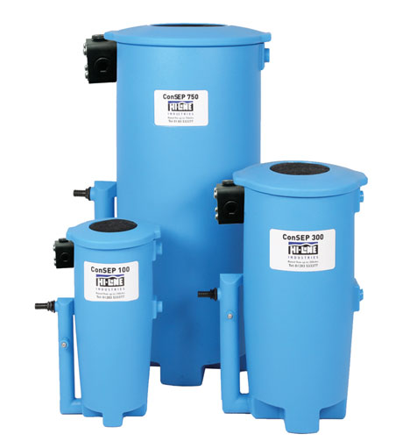
Three models from the ConSEP range of oil/water compressor condensate cleaners, available from Hi-line Industries Ltd.
Download high resolution 300dpi image
Download low resolution 72dpi image

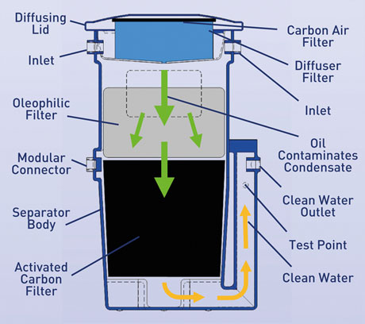
The condensate cleaner process as utilised in the new Hi-Line Industries ConSEP product range.
Download high resolution 300dpi image
Download low resolution 72dpi image

END

