PRESS RELEASE HLI48

RELIABLE PRODUCTION OF COMPLIANT,
HIGH QUALITY BREATHING AIR

The highly successful Atacama range of modular air dryers manufactured by Hi-line Industries Ltd has been extended to incorporate a third filtration tower. This feature ensures full compliance with BS EN 12021 standard ‘Respiratory equipment – Compressed gasses for breathing apparatus’. This is currently the only standard to indicate contaminant levels for breathing air both in the UK and EU.

This product line development ensures that appropriate models in the Atacama range can now be safely utilised in the most demanding environments including medical, pharmaceutical and laboratories together with the chemical and petrochemical industries. In addition, the emergency services and fire brigades have vital need of reliable and high quality breathing apparatus. The Atacama range is also suited for use in a wide range of paint and paint shop related applications as well as tunnel construction, mining, diving and offshore industries, and also including shipyards for welding and tank cleaning operations.

Bulk water, in liquid and gaseous form needs to be eliminated from the breathing air. BS EN 12021 states that this should be at a pressure dewpoint not exceeding –11°C. This is because any water entering the filtration system will render the catalysts useless. This is why on all breathing air purifiers the first stage of the purification process is a desiccant air dryer.

Continued ……

The ‘Atacama – CT’ breathing air dryer is controlled by the proven Hi-line HDC 1 controller. This solid state digital controller not only has an LED digital dewpoint display, but has dewpoint control built-in as standard. This is pre-set on the breathing air application to change over to stand-by once a dewpoint of -15°C PDP is achieved. This ensures security for air quality, whilst also maintaining energy efficiency. Once the air is clean and dry after passing through the desiccant dryer section of the unit, the third vessel containing activated carbon and a catalyst, removes odours, taste substances, oil vapour/ aerosols, carbon monoxide and various other gases.

The fourth new component is a particulate filter, installed to filter out dust particles and carry over from the desiccant. This allows the operator to breath clean, dry and oil free air, free from contaminants.

Further information is available from: Hi-line Industries Ltd,
5 Crown Industrial Estate, Oxford Street, Burton on Trent, Staffordshire DE14 3PG
Telephone: 01283 533377 Fax: 01283 533367
e-mail: enquiries@hilineindustries.com www.hilineindustries.com

(approximately 410 words
including photographic annotation)

Continued ……
General Information

Supplier: Hi-line Industries Ltd

Press Release No: HLI48

Press or publishing inquiries to: Steve Lloyd
Enterprise Marketing Services Ltd
The Coach House, 1 Dunstall Road, Barton under Needwood,
Burton on Trent, Staffordshire, DE13 8AX, UK
Tel: +44 (0) 1283 713185
Fax: +44 (0) 1283 716172
E-mail: info@enterprise-marketing.co.uk

Reader response inquiries to: Mr Steven D Smith
Sales & Marketing Director of Hi-line Industries Ltd

Downloads: The press release text (MS Word and PDF format) and image are
available for download at:

www.enterprise-marketing.co.uk/hli/hli48.html

Our Reference: HLI48/16/06/V4

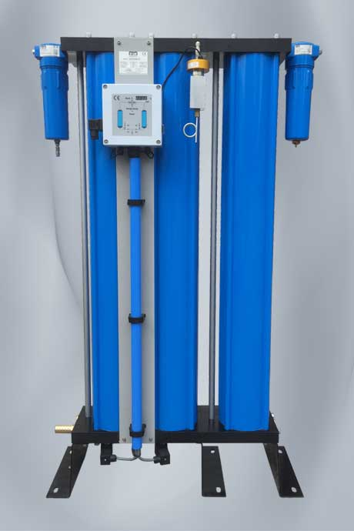
The latest ‘Atacama – CT’ modular dryer unit from Hi-line Industries for the manufacture of BS EN 12021 compliant high quality breathing air.
Download high resolution 300dpi image
Download low resolution 72dpi image

END

