PRESS RELEASE HLI47

HI-LINE ‘COPY EXACT’ ALTERNATIVE FILTERS
COMBINE PERFORMANCE WITH ECONOMY

Hi-line Industries Ltd, the UK air treatment specialists are recognised as the country’s leading supplier of high quality filter elements. With a comprehensive range, in excess of 163,000 different filter element cartridges covered by their design/manufacturing procedures, they are confident in their ability to provide a ‘one-stop’ filtration service for general industry as well as the well established compressed air, gas and vacuum together with the widespread liquids handling and processing markets in this country.

To ensure their ability to service growing demands from the many UK commercial markets, Hi-line offer ‘copy exact’ alternative elements to ensure a simple ‘drop-in and seal’ installation procedure at the point of use. The Hi-line elements available cover not only the compressed air (both coalescing and drying operations), together with the vacuum and breathing-air quality markets, but also the liquids filtration requirements as associated with the chemical, processing, hydraulics, water, medical, breweries, dairies, pharmaceutical and many general food processing establishments.

It is important that these essential filtration components are regularly replaced at recommended service deadlines to prevent potential damage to downstream capital equipment and/or interruptions to production line outputs. The Hi-line ‘one-stop’ filtration service covers the supply of both original OEM filtration elements, as well as their own manufacture of highly-economic alternative cartridges.

Continued ……

Experienced plant engineers are aware that regular maintenance using OEM original equipment cartridges can prove expensive. However, growing numbers are turning to Hi-line’s proven experience in manufacturing ‘copy exact’ alternatives to these OEM filters, taking advantage of prices that can be up to 75% less, all without any detriment to build quality, performance or service life expectancy.

Hi-line alternative elements are manufactured to ISO 8573-1:2010 standards, complying with the necessary compressed air purity classes. Furthermore, in order to deliver over four times the filtration area compared to conventional wrapped or rolled media filters, a Hi-line pleated media construction is utilised, together with high quality stainless steel to ensure a robust solution for all industrial filtration requirements.

Replacement alternative filters supplied by Hi-line are at least performance equal to any original filter elements that need to be replaced. In many cases, however, the Hi-line elements can substantially outperform these OEM products, so then acting as a complete performance upgrade for an established system. The increase in operating performance of a Hi-line filter compared to original fitments can be as impressive as 60%, while the prices of Hi-line products have also remained stabilised for several years.

Among the many additional benefits of alternative filter elements from Hi-line are high flow rates, good dirt holding potential, low differential pressures, less oil carry-over and long service life. Popular filter element sizes are available off the shelf for immediate delivery, with planned delivery schedules also available as required.

Utilising their electronic filter element cross-reference database, Hi-line internal and external sales teams, can quickly identify replacement filter elements for same day dispatch.

Continued ……
Further information is available from: Hi-line Industries Ltd,
5 Crown Industrial Estate, Oxford Street, Burton on Trent, Staffordshire DE14 3PG
Telephone: 01283 533377 Fax: 01283 533367
e-mail: enquiries@hilineindustries.com www.hilineindustries.com

(approximately 570 words
including photographic annotations)

General Information

Supplier: Hi-line Industries Ltd

Press Release No: HLI47

Press or publishing inquiries to: Steve Lloyd
Enterprise Marketing Services Ltd
The Coach House, 1 Dunstall Road, Barton under Needwood,
Burton on Trent, Staffordshire, DE13 8AX, UK
Tel: +44 (0) 1283 713185
Fax: +44 (0) 1283 716172
E-mail: info@enterprise-marketing.co.uk

Reader response inquiries to: Mr Steven D Smith
Sales & Marketing Director of Hi-line Industries Ltd

Downloads: The press release text (MS Word and PDF format) and images are
available for download at:

www.enterprise-marketing.co.uk/hli/hli47.html

Our Reference: HLI47/16/05/V2

Continued ……
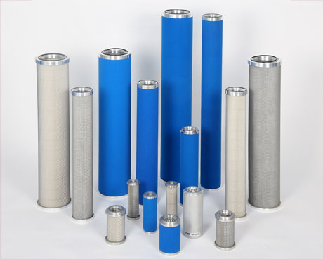
Typical ‘copy exact’ replacement filter elements available from Hi-line Industries Ltd.
Download high resolution 300dpi image
Download low resolution 72dpi image

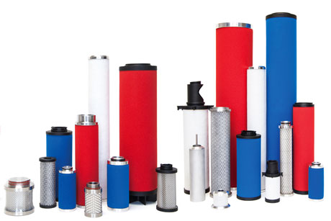
With in excess of 163,000 replacement filter elements now available, Hi-line Industries and able to provide ex-stock deliveries for most popular items.
Download high resolution 300dpi image
Download low resolution 72dpi image

Continued ……

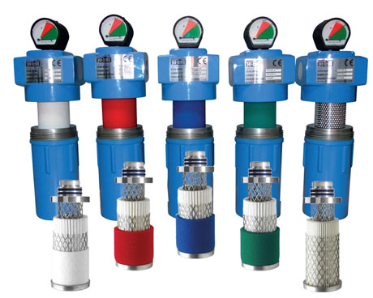
The pleated element configuration of Hi-line replacement products ensure maximum performance with minimum costs as well as straight forward drop-in installation.
Download high resolution 300dpi image
Download low resolution 72dpi image

END

