PRESS RELEASE HLI45

HI-LINE PRESENT NEW CORPORATE MOVIE

Hi-line Industries Ltd, the specialist supplier and installer of efficient compressed air purification equipment is proud to announce that 2016 marks the sixth consecutive year where no price increases have been introduced for any of their product range.

To clarify their activities, Hi-line have produced an informative corporate movie which can be viewed on their website news page. The movie showcases the business, staff members and extensive portfolio of compressed air equipment available.

Since the company’s formation over 15 years ago, Hi-line Industries has built up an enviable reputation for the innovative design, manufacture, supply and installation of energy efficient compressed air purification equipment.

They are now also recognised as the leading UK manufacturers of compressed air dryers, nitrogen & oxygen generators and the most energy efficient range of heat regeneration zero loss adsorption dryers. All of these products are stocked and available with off-the-shelf delivery from the company’s head office. This is based at Burton-on-Trent, in the heart of the country, with excellent transport links throughout the UK.

Hi-line are acknowledged as Britain’s largest stockist of a broad range of air treatment ancillaries and the largest suppliers of refrigeration air dryers, distributed through Hi-line’s well established distributor network of compressed air companies and agents.

Continued ……

Hi-line are also a member of the British Compressed Air Society, and proud to be a part of the "Made in Britain" campaign promoting the best of British manufacturing.

Utilising the latest 3D design CAD software, combined with ongoing investments in personnel, training and development, Hi-line has the best technology and expertise to undertake the development of innovative products and also remain at the leading edge of the industry.

All Hi-line products are designed and built to the highest standards of quality by experienced and qualified engineers. This maintains their confidence in quality of workmanship and materials which is reflected in their five year warranty, ensuring long-term piece of mind for all customers.

Their substantial manufacturing facilities encompass the very latest materials and technologies, backed by a comprehensive array of engineering skills. Quality and excellence are absolutes. As an ISO9001:2008 company, Hi-line’s customers can be assured that processes and performances are constantly monitored, with planning and control also being meticulous.

The Hi-line service department employ some of the most experienced compressed air treatment service personnel in the industry, together with engineers trained in all aspects of compressed air and gas generation. All engineers are ACRIB registered and every engineer is an approved "safe refrigerant handler". Hi-line are also a REFCOM accredited company, this registration scheme supersedes the standards stipulated in the F-Gas Regulations.

Hi-line’s broad range of energy efficient compressed air equipment is used in all types of industry applications including: food, beverage, medical, general manufacturing and engineering, dairy, automotive, breathing air, laser cutting, and many more…

Continued ……
They specialise in the design, manufacture and installation of innovative desiccant and refrigerant air dryers, as well as nitrogen and oxygen generators, condensate systems, heat regenerative adsorption dryers and membrane air dryers which require no electrical power, together with desiccant cartridge filters and exhaust air mufflers which superbly reduce exponentially perceived noise. Filter housings and a wide range of filtration products are also provided.

Hi-line offer both a standard and bespoke range of energy efficient products built to suit specific applications.

As part of Hi-line’s ever growing expansion programme, they have recently appointed Richard Weir as their National Distribution Manager.

Further information is available from: Hi-line Industries Ltd,
5 Crown Industrial Estate, Oxford Street, Burton on Trent, Staffordshire DE14 3PG
Telephone: 01283 533377 Fax: 01283 533367
e-mail: enquiries@hilineindustries.com www.hilineindustries.com

(approximately 680 words
including photographic annotations)
General Information

Supplier: Hi-line Industries Ltd

Press Release No: HLI45

Press or publishing inquiries to: Steve Lloyd
Enterprise Marketing Services Ltd
The Coach House, 1 Dunstall Road, Barton under Needwood,
Burton on Trent, Staffordshire, DE13 8AX, UK
Tel: +44 (0) 1283 713185
Fax: +44 (0) 1283 716172
E-mail: info@enterprise-marketing.co.uk

Reader response inquiries to: Mr Steven D Smith
Sales & Marketing Director of Hi-line Industries Ltd

Downloads: The press release text (MS Word and PDF format) and images are
available for download at:

www.enterprise-marketing.co.uk/hli/hli45.html

Our Reference: HLI45/16/03/V2

Continued ……

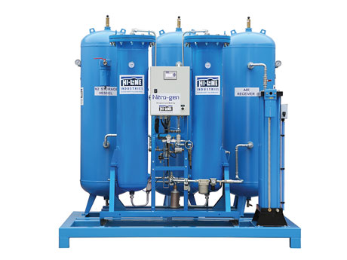
Typical Nitrogen generator, just one of the compressed air equipment products available from Hi-line Industries.
Download high resolution 300dpi image
Download low resolution 72dpi image

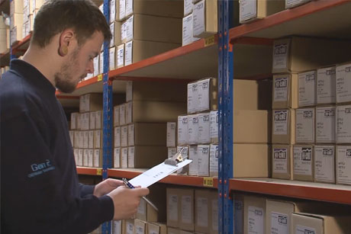
Hi-line products are stocked and available with off-the-shelf delivery from the company’s head office in Burton-on-Trent.
Download high resolution 300dpi image
Download low resolution 72dpi image

Continued ……
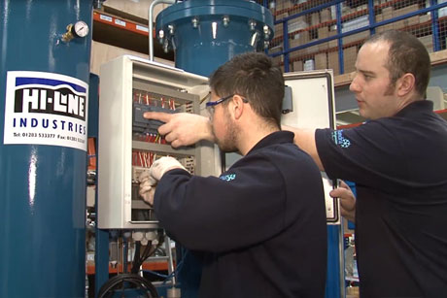
The Hi-line service department employ some of the most experienced compressed air treatment service personnel in the industry.
Download high resolution 300dpi image
Download low resolution 72dpi image

END

