PRESS RELEASE HLI44

MORE DISTRIBUTOR SUPPORT AT HI-LINE

Hi-line Industries Ltd claim to be the compressed air industries leading air treatment company, selling to the compressor service sector via their own well established distributor network.

As part of their continued growth strategy, Hi-line have invested in two regional ‘Distribution Support Managers, who are based geographically in the North and South of the United Kingdom, and also backed-up by internal dedicated support staff.

The “North” will be in the capable hands of a veteran compressed air buff, Simon Bailey. Simon joins the Hi-line team from a German High Pressure Compressor manufacturer, and with over 20 years experience in compressed air, Simon is well placed to offer technical support to all Hi-line distributors.

Based in the centre of his region in Cheshire, Simon is on the doorstep of many Hi-line customers in the North of England. Currently in an extensive training programme with the Hi-line team, he will be supporting distributors by the start of the New Year with a focus on helping all of their resellers get added value from Hi-line and their products.

Simon is married to Carrie and they have a 4 year old son Oliver, and any free time available is spent cycling, circuit training or keeping fit.

Hi-line has also appointed a high calibre Distribution Support Manager for the South of the nation and this will be announced in the New Year.
Continued ......
Further information is available from: Hi-line Industries Ltd,
5 Crown Industrial Estate, Oxford Street, Burton on Trent, Staffordshire DE14 3PG
Telephone: 01283 533377 Fax: 01283 533367
e-mail: enquiries@hilineindustries.com www.hilineindustries.com

(approximately 270 words
including photographic annotations)

General Information

Supplier: Hi-line Industries Ltd

Press Release No: HLI44

Press or publishing inquiries to: Steve Lloyd
Enterprise Marketing Services Ltd
The Coach House, 1 Dunstall Road, Barton under Needwood,
Burton on Trent, Staffordshire, DE13 8AX, UK
Tel: +44 (0) 1283 713185
Fax: +44 (0) 1283 716172
E-mail: info@enterprise-marketing.co.uk

Reader response inquiries to: Mr Steven D Smith
Sales & Marketing Director of Hi-line Industries Ltd

Downloads: The press release text (MS Word and PDF format) and images are
available for download at:

www.enterprise-marketing.co.uk/hli/hli44.html

Our Reference: HLI44/15/12/V1

Simon Bailey, Hi-line’s new Distribution Support Manager covering the North of England.
Download high resolution 300dpi image
Download low resolution 72dpi image
Continued ......
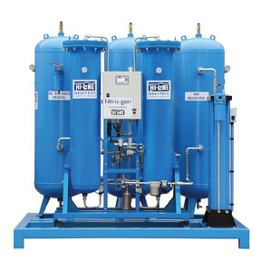
Typical Nitrogen generator, just one of the many airline products available from Hi-line Industries Ltd.
Download high resolution 300dpi image
Download low resolution 72dpi image

END

