PRESS RELEASE HLI43

COMPACT POINT OF USE DRYERS OFFER
HIGH PERFORMANCE AND RELIABILITY

The Atacama range of adsorption dryers manufactured by Hi-line Industries Ltd have an established provenance for successful operation as ‘point of use dryers’ across a wide range of industrial and commercial applications, wherever there is a localised demand for the supply of clean, dry compressed air.

The Atacama products feature twin towers, each filled with desiccant, providing high performance coalescing pre-filtration combined with positive particle after-filtration. Only one single tower is on-line at a time, while a small amount of the dry, compressed air throughput is used to automatically regenerate desiccant in the second off-line tower. The change-over procedure is achieved under the well established PSA (Pressure Swing Adsorption) principle. High rates of reliability are achieved by top quality engineering design and the simple principle of positively driven valves, as opposed to less reliable ‘shuttle valves’ employed on cheaper lower quality dryers. An optional off-the-shelf centrifugal water separator is also available where required for the positive removal of extracted oil & water prior to adsorption. In addition, an energy saving dewpoint controller incorporating ‘LED Dewpoint’ display is also available as an optional extra to provide the most energy efficient drying cycle at all times.

Typical applications for the Atacama products include a wide range of general processing and packaging operations including medical, dental and food, which is complemented with industrial applications such as powder coating, printing, laser technology, plasma cutting, pneumatic controls and many other diverse general engineering fields.
Continued ......

The standard product range covers five models, accommodating flow rate volumes from 5 up to 100cfm of clean, dry air at variable dewpoints from -20°to -40°C. Lower dewpoint models down to -70°C can be supplied.

These compact, space saving design products can be supplied ex-stock as standard with 240V (4-16 bar) operation with 110V operation available upon request. Service kits and maintenance items are also available with the same off-shelf, next day delivery.

Further information is available from: Hi-line Industries Ltd,
5 Crown Industrial Estate, Oxford Street, Burton on Trent, Staffordshire DE14 3PG
Telephone: 01283 533377 Fax: 01283 533367
e-mail: enquiries@hilineindustries.com www.hilineindustries.com

(approximately 370 words
including photographic annotation)

General Information

Supplier: Hi-line Industries Ltd

Press Release No: HLI43

Press or publishing inquiries to: Steve Lloyd
Enterprise Marketing Services Ltd
The Coach House, 1 Dunstall Road, Barton under Needwood,
Burton on Trent, Staffordshire, DE13 8AX, UK
Tel: +44 (0) 1283 713185
Fax: +44 (0) 1283 716172
E-mail: info@enterprise-marketing.co.uk

Reader response inquiries to: Mr Steven D Smith
Sales & Marketing Director of Hi-line Industries Ltd

Downloads: The press release text (MS Word and PDF format) and image are
available for download at:

www.enterprise-marketing.co.uk/hli/hli43.html

Our Reference: HLI43/15/11/V2

Continued ......
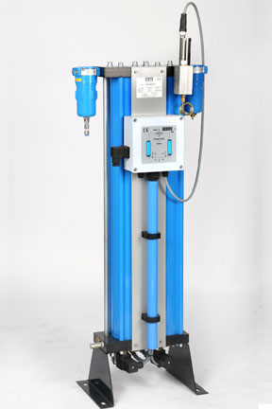
The Atacama range of ‘point of use dryers’, manufactured by Hi-line Industries Ltd, covering a throughput range from 5 to 100cfm of clean, dry compressed air.
Download high resolution 300dpi image
Download low resolution 72dpi image

END

