PRESS RELEASE HLI42

POINT-OF-USE MEMBRANE DRYERS PROVE POPULAR
FOR WIDE VARIETY OF APPLICATIONS

Since Hi-line Industries completely re-engineered its market-leading range of Hi-DRI compressed air membrane dryers, the company reports that strong uptake has seen these technologically advanced units sold into a wide variety of applications. Clearly impressed with the ability of Hi-DRI membrane dryers to deliver superior levels of reliability, performance and energy efficiency, the systems are proving extremely popular with end users seeking ways to make it easier and less expensive to supply pneumatic equipment and instrumentation with clean, dry compressed air. Among the multitude of end user sectors already exploiting the virtues of Hi-DRI membrane dryers are the medical, dental, paint/bodyshop, analytical equipment, robotics and laser printing industries, to list but a few.

The many notable features differentiating Hi-DRI compressed air membrane dryers from competitor units include a patented arrangement of structurally packed, permeable hollow fibres that are spirally wound on a support core. This has the advantageous effect of combining efficient air flow with high contact areas to maximise drying performance.

Another factor in the ongoing success of Hi-DRI systems is their compact, ‘in-line’ design. This makes life easy for compressed air system specifiers and designers, and ensures the products are ideal for in-line installations that guarantee the delivery of dehydrated compressed air to the point of use. Moreover, no electricity or energy supply is required, making these lightweight units ideal for remote, isolated or other challenging requirements.

Continued ......

Offering cost effective and efficient filtration and drying in a single unit, Hi-DRI units offer numerous benefits to end users seeking competitive gain from their compressed air systems. For instance, the membrane construction of the units does not deplete oxygen from compressor, which means it can be used as ‘breathing air’ dryer. Furthermore, there is no condensed H2O to deal with as this is removed as a gas. Indeed, membrane dryers contain no refrigerants whatsoever, making them environmentally friendly.

This simple, proven technology helps eliminate condensation, oxidation and microbial growth (detrimental in food, pharmaceutical, dental, medical or laboratory applications) – all of which are known to result in the poor reliability and performance of downstream air operated equipment. In addition, Hi-DRI membrane dryers do not contain any moving parts, and there are no desiccants or refrigerant to replace. As a consequence, users enjoy a long, maintenance-free service life with low TCO (total cost of ownership).

Almost any dewpoint can be achieved (flexible pressure dewpoint down to -40°C), even when accommodating high humidity ambient conditions as experienced outdoors, in open workshops or on seagoing vessels. As a point of note, Hi-line can also provide pre-filtration, which further enhances the membrane dryer’s efficiency and compressed air quality downstream and at point of use.

Offering low purge air in comparison with desiccant dryers, the range of Hi-DRI membrane air dryers covers air flow rates from 17 to 1050 litres/min. Multiple dryer units can be used in parallel to achieve higher flows where required. Outlet dewpoints from +15° to -40°C can be achieved at 7 barg pressure (12.5 barg max) and with 35°C inlet air temperatures. The dryers are available ex-stock from Hi-line’s Burton-upon-Trent facility ready for next day delivery.

Further information is available from: Hi-line Industries Ltd,
5 Crown Industrial Estate, Oxford Street, Burton on Trent, Staffordshire DE14 3PG
Telephone: 01283 533377 Fax: 01283 533367
e-mail: enquiries@hilineindustries.com www.hilineindustries.com
Continued ......
(approximately 590 words
including photographic annotations)

General Information

Supplier: Hi-line Industries Ltd

Press Release No: HLI42

Press or publishing inquiries to: Steve Lloyd
Enterprise Marketing Services Ltd
The Coach House, 1 Dunstall Road, Barton under Needwood,
Burton on Trent, Staffordshire, DE13 8AX, UK
Tel: +44 (0) 1283 713185
Fax: +44 (0) 1283 716172
E-mail: info@enterprise-marketing.co.uk

Reader response inquiries to: Mr Steven D Smith
Sales & Marketing Director of Hi-line Industries Ltd

Downloads: The press release text (MS Word and PDF format) and image are
available for download at:

www.enterprise-marketing.co.uk/hli/hli42.html

Our Reference: HLI42/15/10/V1

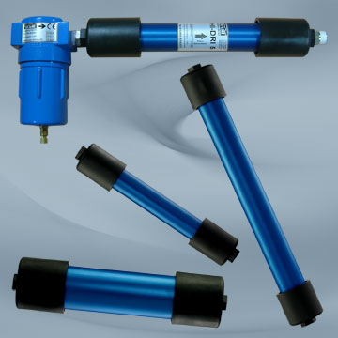

The re-engineered range of high performance HI-DRI compressed air membrane dryers from Hi-line Industries Ltd.
Download high resolution 300dpi image
Download low resolution 72dpi image

Continued ......

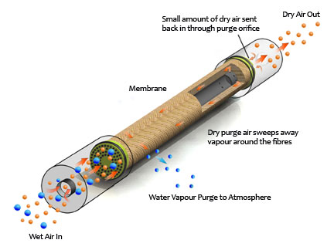
Environmentally friendly filtration/drying membrane units utilised in the latest Hi-line Industries HI-DRI units which help eliminate condensation, oxidation and microbial growth.
Download high resolution 300dpi image
Download low resolution 72dpi image

END

