PRESS RELEASE HLI41

HIGH PURITY OXYGEN GENERATORS

The latest Oxygen (O₂) Generators available from Hi-line Industries Ltd can remove nitrogen from a compressed airline stream to provide air supplies with a range of enhanced oxygen content levels up to 98.5% purity. Normal, dry atmospheric air comprises approximately 78% nitrogen by volume, made up with 21% oxygen and the remaining balance incorporating argon, water vapour, carbon dioxide and other minor trace gases. The increasing reduction of the nitrogen content from compressed air therefore leaves the residual gas with highly enhanced Oxygen content.

The separation of gases is achieved by forcing compressed air through a separation column containing a highly selective Zeolite sieve which adsorbs a large percentage of the nitrogen content in the air. This leaves the residual air that has passed through the separation process with appropriate enhanced levels of O₂ content. A Pressure Swing Absorption (PSA) process is utilised for the twin-column process, so that when the on-line column is saturated with nitrogen, an automatic changeover to the second column of Zeolite processing is undertaken. With 180°phase delay between cycles, a continuous output of highly oxygenated air is maintained.

With purities of up to 98.5% of O₂, oxygen generators can be connected to an external buffer tank or tanks to accommodate delays or variations in production/consumption. The modular philosophy of the Hi-line Oxygen generators allows the installation of multiple parallel units according to application requirements.

Continued ......

The uses of Oxygen produced in this process are many and varied, including the Oxygenation of Bio-Mass systems to enhance burn performance. Such Oxygen is also introduced into the water at fish farms. This enables stocking densities to be increased, with the fish stock being healthier and having a better taste resulting from Oxygen rich environment. Such Oxygen can also be utilised for the leak testing of automotive air conditioning units, or as air cleaners for Ozone generators. Oxygen generators can also help maintain the supply of this important commodity which, as one of the most basic drugs that exist, is widely utilised throughout hospitals for the treatment of acute respiratory infections, asthma, fatal asphyxia and as shock treatments to save patients lives.

A total of fifteen O₂ Generator models are available covering Oxygen flows from 0.125 up to 120.18 Nm³/h, depending upon the Oxygen % levels required.

Further information is available from: Hi-line Industries Ltd,
5 Crown Industrial Estate, Oxford Street, Burton on Trent, Staffordshire DE14 3PG
Telephone: 01283 533377 Fax: 01283 533367
e-mail: enquiries@hilineindustries.com www.hilineindustries.com

(approximately 430 words
including photographic annotation)

Continued ......
General Information

Supplier: Hi-line Industries Ltd

Press Release No: HLI41

Press or publishing inquiries to: Steve Lloyd
Enterprise Marketing Services Ltd
The Coach House, 1 Dunstall Road, Barton under Needwood,
Burton on Trent, Staffordshire, DE13 8AX, UK
Tel: +44 (0) 1283 713185
Fax: +44 (0) 1283 716172
E-mail: info@enterprise-marketing.co.uk

Reader response inquiries to: Mr Steven D Smith
Sales & Marketing Director of Hi-line Industries Ltd

Downloads: The press release text (MS Word and PDF format) and image are
available for download at:

www.enterprise-marketing.co.uk/hli/hli41.html

Our Reference: HLI41/07/15/V2

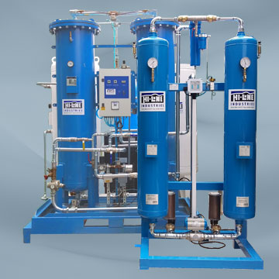
The latest high purity Oxygen generators providing up to 98.5% purity, now available from Hi-line Industries Ltd.
Download high resolution 300dpi image
Download low resolution 72dpi image

END

