PRESS RELEASE HLI40

GROWING DEMAND FOR LATEST
TUNDRA REFRIGERATION DRYERS

The latest Tundra refrigeration air dryers from Hi-line Industries Ltd offer even more benefits to potential users of these advanced products. With an ever expanding customer list, the Tundra range, which was first introduced in 2012, continues to prove popular in a host of industrial applications. And it’s easy to see why. For instance, not only is the range designed with energy efficiency and reliability in mind, but the breadth of choice – there are no less than 16 models available in the standard range (available ex-stock) – means dryers with air throughput from 35 to 2727 m³hr can be selected. Among recently added features is an ultra-high efficiency heat exchanger. Any customers interested in a new Tundra refrigeration air dryer might also like to know that for a limited time, Hi-line is giving away a free barrel of beer with every order.

The use of refrigeration drying for compressed air treatment is well proven for many applications, in fact wherever there is a requirement for a general removal of bulk water and vapour. Refrigerated air dryers can be used at low pressures as well as high pressures, and use no processed compressed air during air treatment. Of course, proper sizing factors must be used to determine the correct dryer for the application based on actual (or worst case) flow, operating temperature and operating pressure. Hi-line experts are always available to advise customers on specification.

Continued ……

With an operating pressure of 4 to 16 barg and a dew point indicator as standard (digital on larger models), the Tundra range is a well specified, proven performer. The maximum inlet air temperature is 60ºC, while ambient air temperature is 0ºC to 50ºC. Furthermore, unlike thermal mass dryers, the Tundra range of refrigeration air dryers maintain a constant +3ºC dew point at all times.

The aforementioned ultra-high efficiency heat exchanger differs from other designs in that the flow mixing chamber can be found at the outlet of the air/air exchanger. As a result, air temperatures are stabilised with a uniform air flow entering the evaporator, thus allowing for optimum exchange within the refrigerant fluid. What’s more, the heat exchanger delivers a very low differential drop across the dryer, ensuring users benefit from maximised energy savings. In short, the zero-loss Tundra range has been designed from top to bottom with the customer in mind.

In total, 11 of the standard, ex-stock Tundra range run off a 230V single phase supply with the remaining five models requiring a 400V three-phase connection. For those requiring higher pressures, units offering operation at 50 barg can be produced to order, along with bigger dryers delivering higher flow rates.

Further information is available from: Hi-line Industries Ltd,
5 Crown Industrial Estate, Oxford Street, Burton on Trent, Staffordshire DE14 3PG
Telephone: 01283 533377 Fax: 01283 533367
e-mail: enquiries@hilineindustries.com www.hilineindustries.com

(approximately 500 words
including photographic annotation)

Continued ……
General Information

Supplier: Hi-line Industries Ltd

Press Release No: HLI40

Press or publishing inquiries to: Steve Lloyd
Enterprise Marketing Services Ltd
The Coach House, 1 Dunstall Road, Barton under Needwood,
Burton on Trent, Staffordshire, DE13 8AX, UK
Tel: +44 (0) 1283 713185
Fax: +44 (0) 1283 716172
E-mail: info@enterprise-marketing.co.uk

Reader response inquiries to: Mr Steven D Smith
Sales & Marketing Director of Hi-line Industries Ltd

Downloads: The press release text (MS Word and PDF format) and image are
available for download at:

www.enterprise-marketing.co.uk/hli/hli40.html

Our Reference: HLI40/15/04/V1

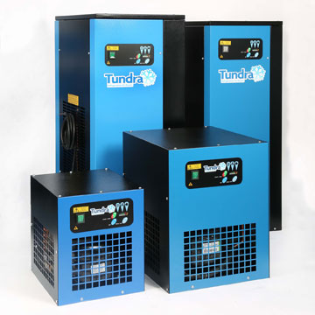
Four of the 16 Tundra refrigeration dryer models available ex-stock from Hi-line Industries Ltd, covering throughput capacities from 35 to 2727 m³hr.
Download high resolution 300dpi image
Download low resolution 72dpi image

END

