PRESS RELEASE DL047

SEALS DELIVER LONG LIFE IN
CHEMICAL PROCESSING APPLICATIONS

Based on a proprietary and patented crosslinking system that has been developed specifically for the chemical processing industry, DuPont™ Kalrez® Spectrum™ 7275 seals exhibit minimal swelling and improved retention of physical properties when exposed to aggressive chemicals such as concentrated nitric acid, organosilanes, chlorosilanes, pure ethylene oxide, butyraldehyde, amines, vinyl monomers and acrylic monomers. Kalrez® 7275 seals are available in the UK from authorised distributor Dichtomatik Ltd.

Any process plant that uses chemicals as an inherent part of its operations knows the importance of reliable, long-lasting seal technology. With Kalrez® 7275, which is a special perfluoroelastomer product, users enjoy excellent compression set resistance and good retention of physical properties after ageing at high temperatures. In fact, the seals will deliver a higher level of performance in any aggressive chemical processing application with temperatures up to 300°C, especially where high resistance to strong oxidisers such as nitric acid, chlorine and chlorine dioxide is required.

Continued ……

Among those able to vouch for the benefits of Kalrez® 7275 is a paper mill in North America that relies on chlorine dioxide for its pulp bleaching operations. The paper mill was experiencing frequent failures of a pump handling chlorine dioxide in water. According to the reliability engineer, the incumbent non-black FFKM seal typically failed within 5 months of installation because of the extremely aggressive nature of the stream. However, following replacement of the seals with Kalrez® 7275, seal life doubled to more than 12 months, removing the pump from the paper mill’s list of “bad performers” and into routine yearly maintenance. Increasing the MTBR (mean time between repair) in this way contributes to reduced maintenance costs and longer equipment life, while improving process safety.

Aside from pumps, Kalrez® 7275 will benefit many other applications which depend on mechanical seals as part of their critical processes, including valves, compressors, filtration columns and analytical equipment.

Uniquely identifiable by its light brown colour, Kalrez® 7275 offers: a Shore hardness (A) of 75 (on the slab) and 81 Shore M (on the O Ring); 100% Modulus of 9.7 MPa; tensile strength at break of 14.5 MPa; elongation at break of 160%; and compression set of 22% (70 hours at 204°C). The product is available in a broad series of standard O-ring sizes and custom parts for a wide range of sealing applications.

Further information is available from:
Dichtomatik Ltd, Donington House, Riverside Road, Pride Park, Derby DE24 8HX
Telephone: 01332 524401
e-mail: kalrez@dichtomatik.co.uk www.dichtomatik-kalrez.co.uk

(approximately 470 words
including photographic annotations)

Continued ……
General Information

Supplier: Dichtomatik Ltd

Press Release No: DL047

Press or publishing inquiries to: Steve Lloyd
Enterprise Marketing Services Ltd
The Coach House, 1 Dunstall Road, Barton under Needwood,
Burton on Trent, Staffordshire, DE13 8AX, UK
Tel: +44 (0) 1283 713185
Fax: +44 (0) 1283 716172
e-mail: stevelloyd@enterprise-marketing.co.uk

Reader response inquiries to: Mr D Cook of Dichtomatik Ltd (david@dichtomatik.co.uk)

Downloads: The press release text (MS Word and PDF format) and images are
available for download at:

www.enterprise-marketing.co.uk/dl/dl047.html

Our Reference: DL047/06/19/V2

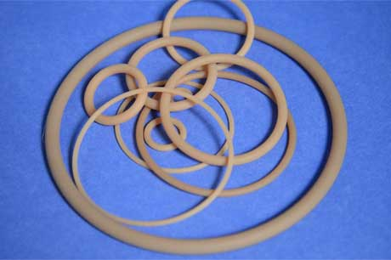
DuPont™ Kalrez® Spectrum™ 7275 seals exhibit minimal swelling and improved retention of physical properties when exposed to aggressive chemicals.
Download high resolution 300dpi image
Download low resolution 72dpi image

Continued ……
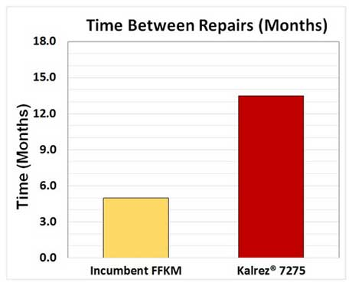
Durability of Kalrez® Spectrum™ 7275 relative to the MTBR of the incumbent FFKM in a chlorine dioxide/water stream.
Download high resolution 300dpi image
Download low resolution 72dpi image

Pump seal life was more than doubled when using Kalrez® 7275 seals at a paper mill in North America.
Download high resolution 300dpi image
Download low resolution 72dpi image
END

