PRESS RELEASE DL046

KALREZ® LS390 SANITARY SEALS EXCEL IN
FOOD AND PHARMACEUTICAL APPLICATIONS

The DuPont™ Kalrez® LS390 series of perfluoroelastomer sanitary seals have been designed specifically for use in sectors that include life science, food and beverage, and pharmaceutical. Class-leading Kalrez® LS390 provides longer seal life and tighter sealing, which improves productivity and process optimisation. Moreover, the new seals create a safer environment in the day-to-day running of process plants and manufacturing facilities. Kalrez® LS390 seals are available in the UK from authorised distributor Dichtomatik Ltd.

There are a number of problems that can be experienced in sanitary seal applications, many of which are related to thermal and chemical resistance challenges, compression set (permanent deformation), and high static friction (stiction). Such issues can lead to intrusion in the production line or dead space, which in turn elevates the risk of contamination or leakage.

Kalrez® LS390 has been purpose-designed to overcome these common challenges by providing high hardness properties (Shore A3 88), low stiction, temperature resistance up to 220°C and outstanding chemical resistance to process chemicals, WFI (water for injection), and SIP and/or CIP processes. For users, these properties facilitate greater MTBR (mean time between repair), delivering bottom-line cost savings.

Continued ……
Among early adopters of the parts is a major pharmaceutical plant in Japan. Here, Kalrez® LS390 has successfully been deployed in an infusion-drop product operation that uses pure steam SIP. The manufacturer chose Kalrez® LS390 because of its improved chemical resistance and low stiction performance.

Problems had been experienced previously with the company’s existing material (silicone rubber seals), which had issues with steam resistance and high stiction, resulting in a short maintenance period of six months. However, after switching to Kalrez® LS390, the performance improvements have been substantial; the sanitary seals provide excellent resistance to chemicals and pure steam SIP, lasting a year without any damage on the contacting surface. These performance attributes have helped to increase productivity, lower maintenance costs and minimise unscheduled downtime, resulting in lower TCO (total cost of ownership).

As a result of their unique grey colour, LS390 sanitary seals offer easy identification for correct material selection and application. The perfluoroelastomer can also be used in applications other than sanitary seals. To discuss this possibility, please in the first instance contact Dichtomatik Ltd.

Further information is available from:
Dichtomatik Ltd, Donington House, Riverside Road, Pride Park, Derby DE24 8HX
Telephone: 01332 524401 Fax: 01332 524425
e-mail: kalrez@dichtomatik.co.uk www.dichtomatik-kalrez.co.uk

(approximately 375 words
including photographic annotations)

Continued ……
General Information

Supplier: Dichtomatik Ltd

Press Release No: DL046

Press or publishing inquiries to: Steve Lloyd
Enterprise Marketing Services Ltd
The Coach House, 1 Dunstall Road, Barton under Needwood,
Burton on Trent, Staffordshire, DE13 8AX, UK
Tel: +44 (0) 1283 713185
Fax: +44 (0) 1283 716172
e-mail: info@enterprise-marketing.co.uk

Reader response inquiries to: Mr D Cook of Dichtomatik Ltd

Downloads: The press release text (MS Word and PDF format) and images are
available for download at:

www.enterprise-marketing.co.uk/dl/dl046.html

Our Reference: DL046/02/19/V1

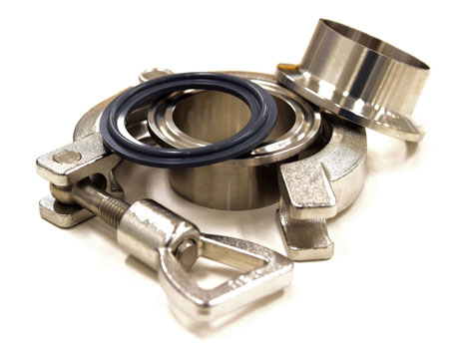
Sanitary seal using DuPont™ Kalrez® LS390, available in the UK from Dichtomatik Ltd.
Download high resolution 300dpi image
Download low resolution 72dpi image

Continued ……
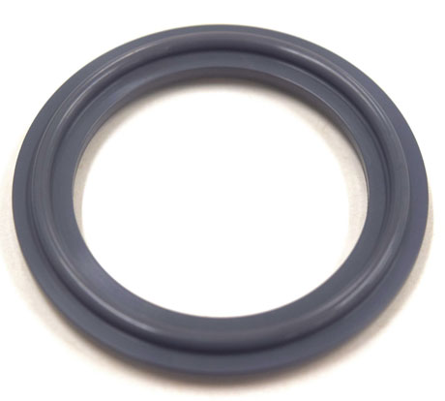
The DuPont™ Kalrez® LS390 series of perfluoroelastomer sanitary seals provide long seal life and tight sealing in sectors that include life science, food and beverage, and pharmaceutical.
Download high resolution 300dpi image
Download low resolution 72dpi image
END

