PRESS RELEASE DL045

NEW KALREZ® 7375 RANGE OF FFKM SEALING PRODUCTS OFFER OUTSTANDING PROPERTIES & PERFORMANCE

The new DuPont™ Kalrez® 7375 innovative FFKM sealing products provide high temperature as well as broad chemical and water/steam resistance properties. Sealing performance, reliability and safety are ensured for applications in the most demanding industrial, chemical and general industrial fields of operation. These high performance perfluoroelastomer O-ring components are available from Dichtomatik Ltd, the authorised distributor for a wide range of DuPont™ finished O-rings, as well as custom shapes, sheets and cord sealing components.

The Kalrez® 7375 parts are tailored for specialised chemical applications covering broad operating temperatures from -20°C to 300°C. These products, which incorporate patented cross linking technology, combine both superior chemical resistance with a thermal stability which exceeds many other competitive FFKM products. They are also available in most standard O-ring sizes including AS568, metric and JIS, with custom sizes and shapes also available on request.

Continued ……

In addition the Kalrez® 7375 product range exhibits an excellent compression set resistance incorporating outstanding physical property retention, while also maintaining good mechanical strength properties even under highly aggressive performance conditions. Excellent sealing properties can be maintained under the most aggressive operating conditions for pumps, valves and compressors, together with associated connectors, vessel lids, filtration and distillation columns, as well as flowmeters and analytical equipment.

These sealing products also provide the broadest chemical and temperature resistance (water and steam), as well as long-term compression-set resistance for hot air at temperatures up to 300°C. These features are also coupled with good compression stress relaxation of the sealing product, as well as an excellent resistance to a broad range of chemicals which ensures low volume changes when operating with products such as Acetic Acid, Maleic Anhydride and Ammonium Hydroxide at 100°C temperatures, together with a 98% Sulphuric Acid content product at 150°C.

Further information is available from:
Dichtomatik Ltd, Donington House, Riverside Road, Pride Park, Derby DE24 8HX
Telephone: 01332 524401 Fax: 01332 524425
e-mail: kalrez@dichtomatik.co.uk www.dichtomatik-kalrez.co.uk

(approximately 360 words
including photographic annotation)

Continued ……

General Information

Supplier: Dichtomatik Ltd

Press Release No: DL045

Press or publishing inquiries to: Steve Lloyd
Enterprise Marketing Services Ltd
The Coach House, 1 Dunstall Road, Barton under Needwood,
Burton on Trent, Staffordshire, DE13 8AX, UK
Tel: +44 (0) 1283 713185
Fax: +44 (0) 1283 716172
e-mail: info@enterprise-marketing.co.uk

Reader response inquiries to: Mr D Cook of Dichtomatik Ltd

Downloads: The press release text (MS Word and PDF format) and image are
available for download at:

www.enterprise-marketing.co.uk/dl/dl045.html

Our Reference: DL045/04/18/V1

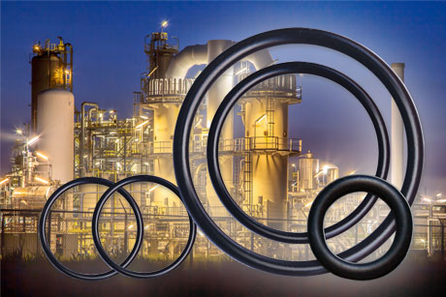
DuPont™ Kalrez® 7375 perfluoroelastomer parts are an innovative FFKM product tailored for chemical process industry applications where broad chemical and water/steam resistance are needed at elevated temperatures.
Download high resolution 300dpi image
Download low resolution 72dpi image
END

