PRESS RELEASE DL044

DUPONT™ KALREZ® PORTFOLIO OPTIMISES
LIFE SCIENCES SECTOR PRODUCTION

The LS222 perfluoroelastomer product recently launched in the DuPont™ Kalrez® range of high performance sealing products is available in the UK from Dichtomatik Ltd, an official authorised DuPont™ Kalrez® distributor. This product range has been designed specifically for operation in the Life Science markets including pharmaceutical and medical packaging together with the food and beverage industries.

The excellent dynamic qualities provided by the Kalrez® product include operation at elevated temperature levels combined with optimal chemical resistance to ensure that these sealing products can be successfully utilised in a wide range of devices including aerosol rings, infusion hangers, microvalves, needle covers, plungers and serum stoppers etc.

Typical applications that include pharmaceuticals production include safety and butterfly valves, granulators and both mechanical and sanitary seals. Applications associated with food and beverage production include stirrers, together with homogenising, filling and bottling equipment, as well as sterilisation and O-ring seals plus sanitary gaskets and custom parts.

Continued ……

This LS222 (FFKM) range offers both reliability and performance, providing best in class FDA – compliant seals, having both appropriate elastomeric properties and high endurance and sealing level capabilities. These products combine performance, efficiency and cleanliness, making them an ideal replacement in markets where PTFE components have previously been the seal material of choice.

The FFKM products feature high thermal and steam tolerance up to 327°C, as well as extensive chemical resistance qualities to over 1800 different chemicals. They ensure long-term performance with minimal seal changes and equipment repairs, leading to fewer inspection requirements and increased production-up times and yields. Kalrez® parts have proven to provide superior sealing and longer service life when compared to lower performing elastomers, resulting in longer, more effective performance combined with increased safety and more efficient production processes.

The LS222 products represent a major expansion to the Kalrez® range to meet demands from equipment OEMS who require high volumes of specific high quality sealing components (ie applications requiring FDA and/or USP VI certification). Typically such applications cover more than 10,000 parts per order, with packages of 500 pieces per bag. These requirements are typically for
O-ring and custom parts featuring outer diameters up to 2” (50.8mm). However, alternative sizes and special shapes can also be manufactured to order.

Manufacturers operating in the critical Life Sciences fields can utilise the high volume LS222 product range to achieve reductions in their total operating costs resulting from the excellent and universal chemical and temperature resistance as well as extended seal life being achieved. They will be able to operate with reduced overall plant sealing costs compared to other perfluoroelastomers, enabling more efficient sealing together with higher quality and cost effective production procedures resulting in maximum outputs.

Continued ……
Further information is available from:
Dichtomatik Ltd, Donington House, Riverside Road, Pride Park, Derby DE24 8HX
Telephone: 01332 524401 Fax: 01332 524425
e-mail: kalrez@dichtomatik.co.uk www.dichtomatik-kalrez.co.uk

(approximately 500 words
including photographic annotation)

General Information

Supplier: Dichtomatik Ltd

Press Release No: DL044

Press or publishing inquiries to: Steve Lloyd
Enterprise Marketing Services Ltd
The Coach House, 1 Dunstall Road, Barton under Needwood,
Burton on Trent, Staffordshire, DE13 8AX, UK
Tel: +44 (0) 1283 713185
Fax: +44 (0) 1283 716172
e-mail: info@enterprise-marketing.co.uk

Reader response inquiries to: Mr D Cook of Dichtomatik Ltd

Downloads: The press release text (MS Word and PDF format) and image are
available for download at:

www.enterprise-marketing.co.uk/dl/dl044.html

Our Reference: DL044/04/17/V1

Continued ……
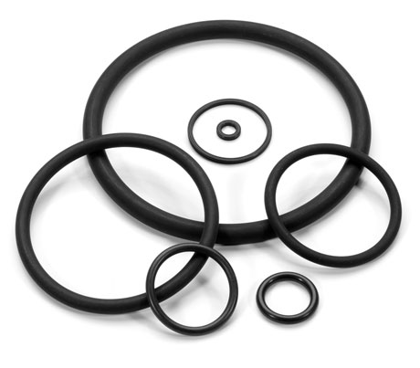
Kalrez LS222 seals are designed specifically for Life Science markets including pharmaceutical and medical packaging together with the food and beverage industries.
Download high resolution 300dpi image
Download low resolution 72dpi image
END

