PRESS RELEASE DL043

HIGH PERFORMANCE SEALS EXTEND
PROCESS EQUIPMENT OPERATING TIMES BY 6000%

DuPont™ Kalrez® Spectrum™ 6375 perfluoroelastomer O-ring seals have been chosen by a major European manufacturer in the AgroSciences marketplace to replace PTFE sealing products previously utilised in their manufacturing equipment. Plant processes included aggressive solvents, surfactants and concentrated herbicides at temperatures ranging from 10 to 45°C, and operating pressures from 1.5 to 3.5 bars Efl. Filling machine valves on the line were previously fitted with dynamic PTFE O-ring seals, while the machine hoses were equipped with static seals, also of PTFE. Each time seal replacements or clean-in-place procedures were performed at 80°C, this resulted in mechanical damage to PTFE seals. Subsequently PTFE O-ring replacement was being undertaken on a daily basis.

In addition the effect of steam on FKM O-rings generated product embrittlement and volume swell, causing surface cracking, reducing tensile strength and leading to premature loss of sealing force and eventual process leakages. The costs in loss of productive time and increased maintenance became unacceptable, coupled with the need for a more resilient sealing material that would withstand frequent cleaning and product changes, while providing extended seal lifetimes.

Continued ……

As a result of adopting the 6375 product, the previously daily procedure of seal replacements for their filling line equipment has been extended to an average of a two monthly procedure. This has achieved a 6000% improvement for their filler machine equipment, while a similar replacement of FEP/FKM seals on other equipment has extended plant operating times from an average 8 hour period to a substantially higher MTBF period of between 8 – 12 months. Since switching the Kalrez® Spectrum™ 6375 custom O-rings, the manufacturer has substantially increased their operation uptimes for filling machines, as well as achieving improved overall reliability of packing lines. A significant result in the reduction of O-ring replacements has also led to increased production with accompanying improvements in safety and reliability, as well as reducing general plant maintenance requirements.

Kalrez® perfluoroelastomer parts are available in the UK from the official DuPont™ licensee company Dichtomatik Ltd. Kalrez® Spectrum™ 6375 components have been designed specifically for applications in the chemical processing industries. These products also combine innovative polymer and cure technologies to ensure outstanding performance with an extensive selection of chemicals and operation at excessive temperature levels. The range of aggressive fluids handled includes acids, bases, amines, steam, ethylene oxide and many other even more hazardous chemicals.

These once problematic fluid mixed streams encountered with chemical processors can now be safely and effectively handled by the 6375 compound, which enables an upper service temperature of 275°C (527°F). This level is approximately 100°F higher than competitive products that also claim suitability for broad chemical resistance applications. The high temperature stability achieved with the 6375 compound range is also applicable even where short duration temperature excess also occurs.

Further information is available from:
Dichtomatik Ltd, Donington House, Riverside Road, Pride Park, Derby DE24 8HX
Telephone: 01332 524401 Fax: 01332 524425
e-mail: kalrez@dichtomatik.co.uk www.dichtomatik-kalrez.co.uk
Continued ……
(approximately 520 words
including photographic annotation)

General Information

Supplier: Dichtomatik Ltd

Press Release No: DL043

Press or publishing inquiries to: Steve Lloyd
Enterprise Marketing Services Ltd
The Coach House, 1 Dunstall Road, Barton under Needwood,
Burton on Trent, Staffordshire, DE13 8AX, UK
Tel: +44 (0) 1283 713185
Fax: +44 (0) 1283 716172
e-mail: info@enterprise-marketing.co.uk

Reader response inquiries to: Mr D Cook of Dichtomatik Ltd

Downloads: The press release text (MS Word and PDF format) and image are
available for download at:

www.enterprise-marketing.co.uk/dl/dl043.html

Our Reference: DL043/03/17/V1

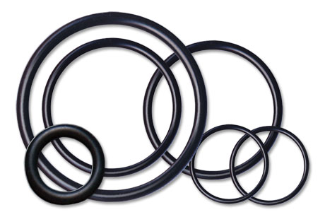

High performance DuPont™ Kalrez® seals, available in the UK from Dichtomatik Ltd, have helped extend the life of process equipment by 6000%.
Download high resolution 300dpi image
Download low resolution 72dpi image
END

