PRESS RELEASE DL041

HIGH PERFORMANCE SEALS FOR CHALLENGING
OIL & GAS ENVIRONMENTS

Dichtomatik Ltd, an approved supplier for the DuPont™ range of high performance
O-ring seals and gaskets, has extended their stock range of sealing components, including specifically designed items for the high pressure / high temperature (HPHT) conditions as encountered in the demanding oil and gas production and development environments. High performance seals such as Viton® fluoroelastomers have been used in extraction, refining and upgrading industries for over five decades.

Typical installations have successfully solved critical sealing problems where elastomers such as nitrile or EPDM have failed to provide an effective long-term sealing performance. Later developments have seen the introduction of DuPont™ Kalrez® perfluoroelastomer parts which can withstand operating conditions involving attack from a range in excess of 1800 chemicals, solvents and plasmas, even where incorporating working conditions up to 327°C (620°F) are utilised.

Continued ......
Viton® outlasts nitrile rubber and other general-purpose elastomers and is ISO 9000 registered worldwide. The ability of this product to withstand both high heat and low temperatures as well as attack from aggressive fuels and chemicals, makes it an ideal medium for the production of protective coatings as well as O-rings, together with gaskets in a wide variety of custom shapes and sizes. This proven versatility ensures that user customers can utilise longer maintenance intervals for production processes, ensuring budget reductions particularly for down-hole applications which can involve particularly hard access conditions.

The Kalrez® parts are particularly suitable for HTPT seal applications, providing long-term performances over a wide spectrum of oil and gas industry working requirements. These perfluoroelastomer (FFKM) parts are highly resistant to aggressive chemicals and solvents, including sour multi-phase fluids. O-ring seals retain high levels of elasticity and recovery, even after long-term exposures at elevated temperatures. The Kalrez® parts for HPHT down-hole environments also provide outstanding rapid gas decompression (RGD) resistance. In fact, rigorous third party laboratory testing for RGD resistance have recorded Kalrez® 0090 AS568-312 O-rings with the highest possible rating of 0000 per the NORSOK M-710 Rev 2 standard.

The performance benefits that have been achieved by the DuPont™ range of products have also extended the MTBR duration from days for some installations to months and even years for other specific applications. These results ensure considerable savings on site downtimes and loss of production, together with savings on manpower costs as plant repair times can be drastically reduced as well as loss of process products through leakages resulting from sealing failures.

Continued .....
Further information is available from:
Dichtomatik Ltd, Donington House, Riverside Road, Pride Park, Derby DE24 8HX
Telephone: 01332 524401 Fax: 01332 524425
e-mail: kalrez@dichtomatik.co.uk www.dichtomatik-kalrez.co.uk

(approximately 490 words
including photographic annotations)

General Information

Supplier: Dichtomatik Ltd

Press Release No: DL041

Press or publishing inquiries to: Steve Lloyd
Enterprise Marketing Services Ltd
The Coach House, 1 Dunstall Road, Barton under Needwood,
Burton on Trent, Staffordshire, DE13 8AX, UK
Tel: +44 (0) 1283 713185
Fax: +44 (0) 1283 716172
e-mail: info@enterprise-marketing.co.uk

Reader response inquiries to: Mr D Cook of Dichtomatik Ltd

Downloads: The press release text (MS Word and PDF format) and images are
available for download at:

www.enterprise-marketing.co.uk/dl/dl041.html

Our Reference: DL041/06/16/V1

Continued .....

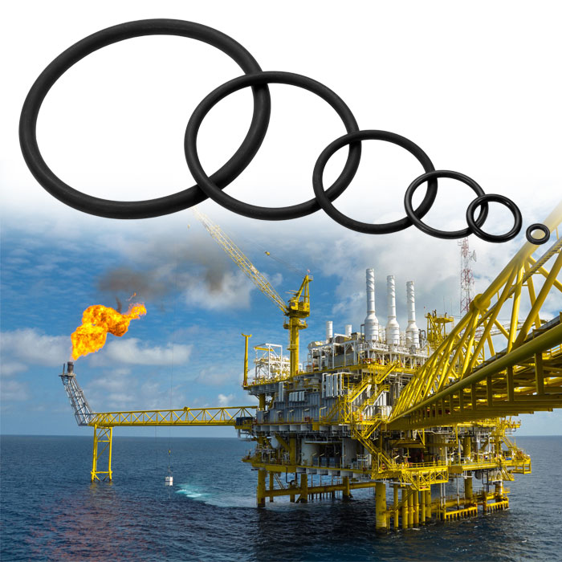
High performance seals available from Dichtomatik Ltd for downhole environments and rapid gas decompression conditions as experienced on offshore oil and gas operations.
Download high resolution 300dpi image
Download low resolution 72dpi image

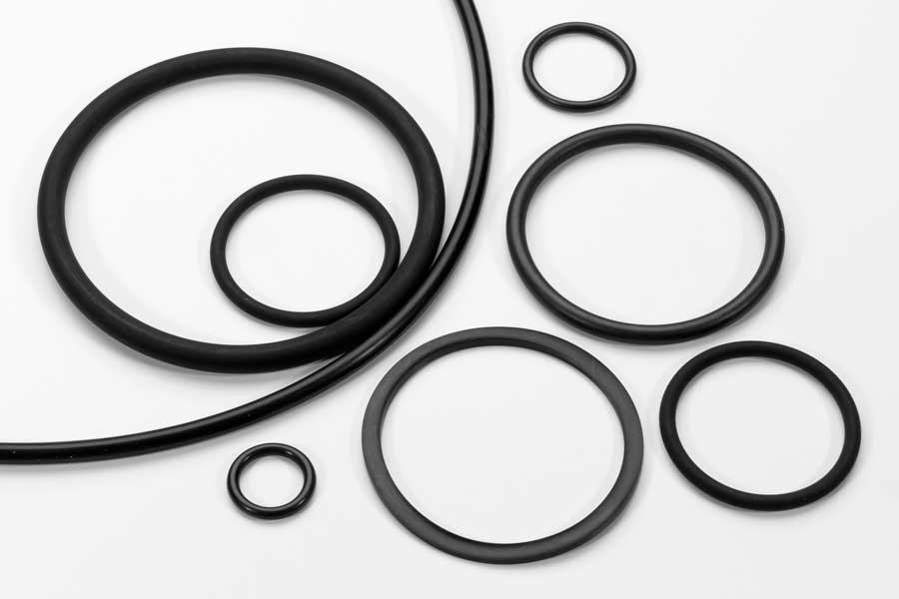
Typical DuPont™ Kalrez® and Viton® high performance O-ring seals, specifically designed for high pressure, high temperature operating conditions.
Download high resolution 300dpi image
Download low resolution 72dpi image

END

